Zaman Cargo :
Project Overview: Web-Based System for Managing Client Deals and International Cargo Transactions
This project involves developing a comprehensive web-based system designed to streamline and manage client deals and customer data for an international cargo business. The system will be responsible for handling all aspects of cargo transactions, including the following key features:
- Client and Customer Data Management:
The system will maintain detailed profiles for all clients and customers, enabling efficient tracking and management of client interactions and business transactions.
- Invoice Generation and Transaction Tracking:
It will automate the generation of invoices for cargo transactions, ensuring accurate billing and record-keeping. The system will also track all transactions, providing a clear overview of financial activities.
- Balance Sheet Management:
The system will automatically update and manage balance sheets for each client, offering real-time financial data, including outstanding balances, payments received, and overall account status.
- Automation of Processes:
By automating core functions such as invoicing, balance sheet updates, and transaction tracking, the system reduces manual input, increasing accuracy and operational efficiency.
This project is ideal for cargo and logistics businesses looking to streamline their operations, improve financial accuracy, and enhance overall client management. The goal is to develop a user-friendly, secure, and scalable platform that meets the unique needs of international cargo transactions.

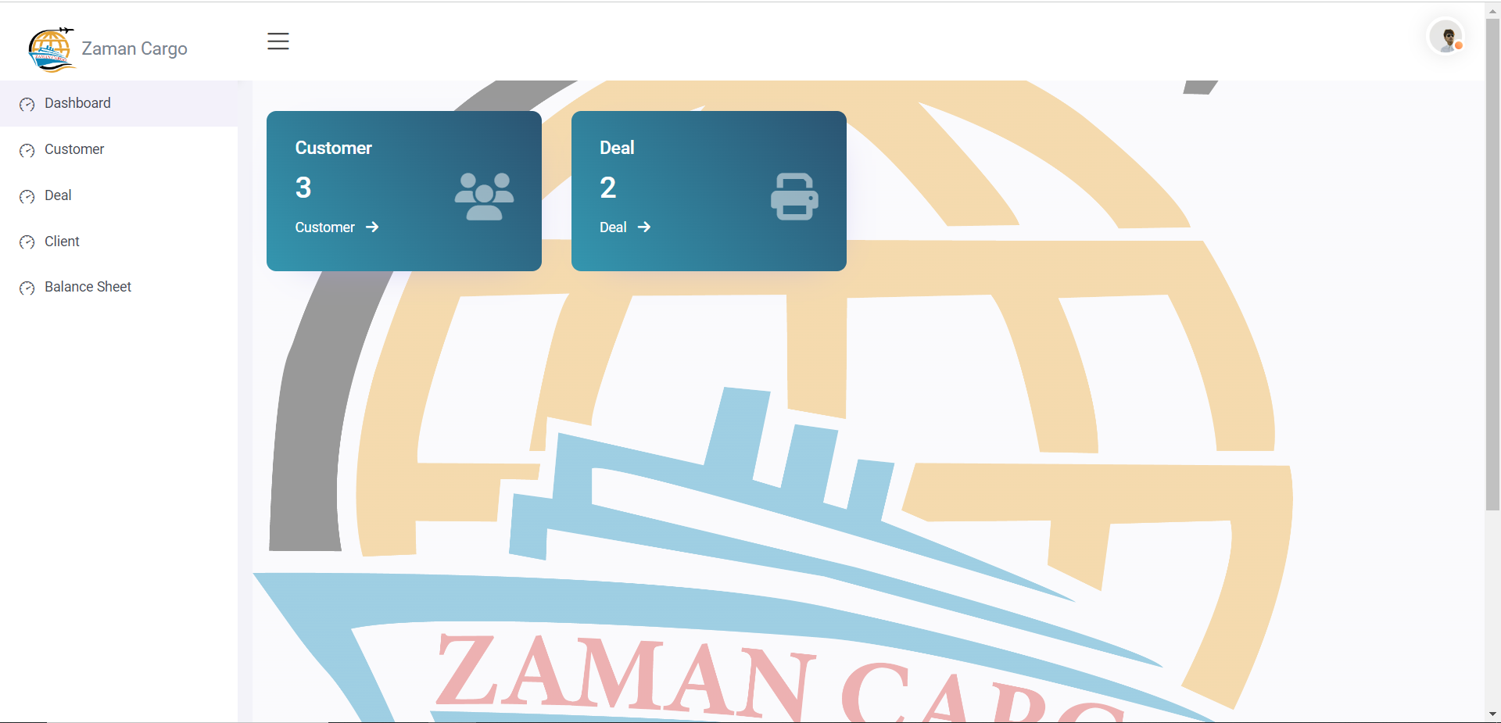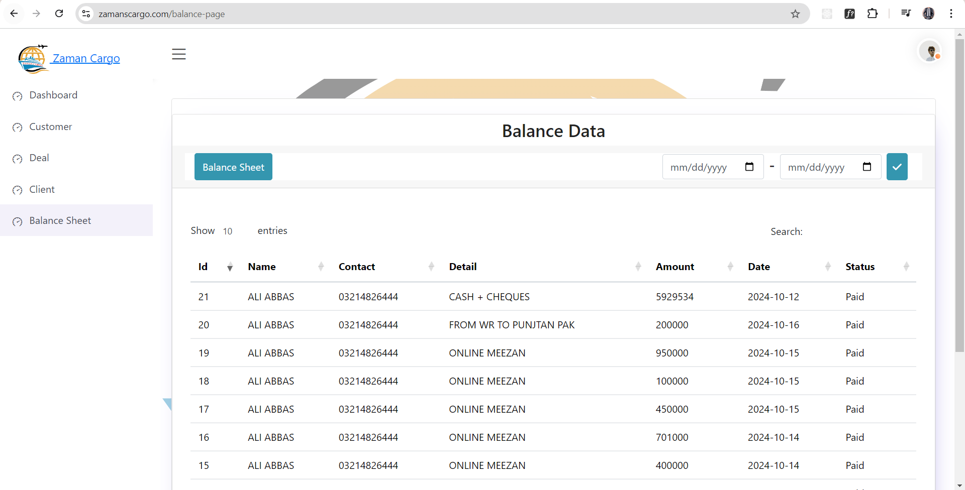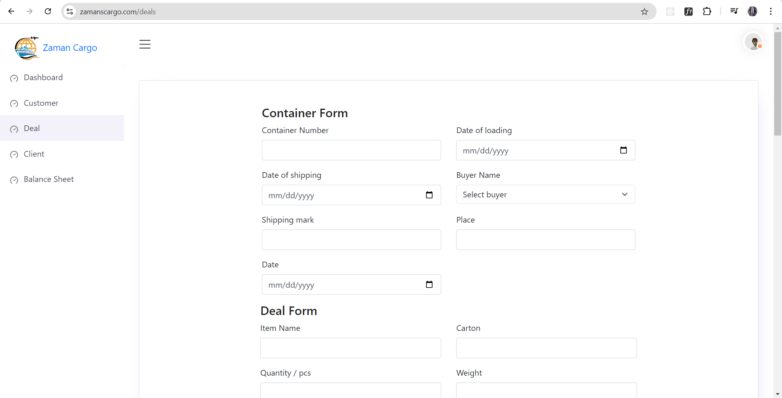++
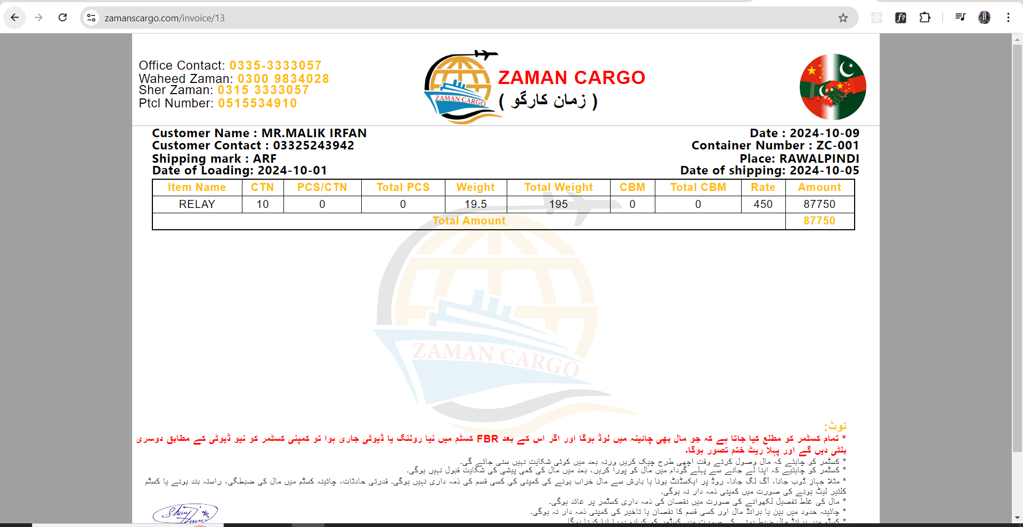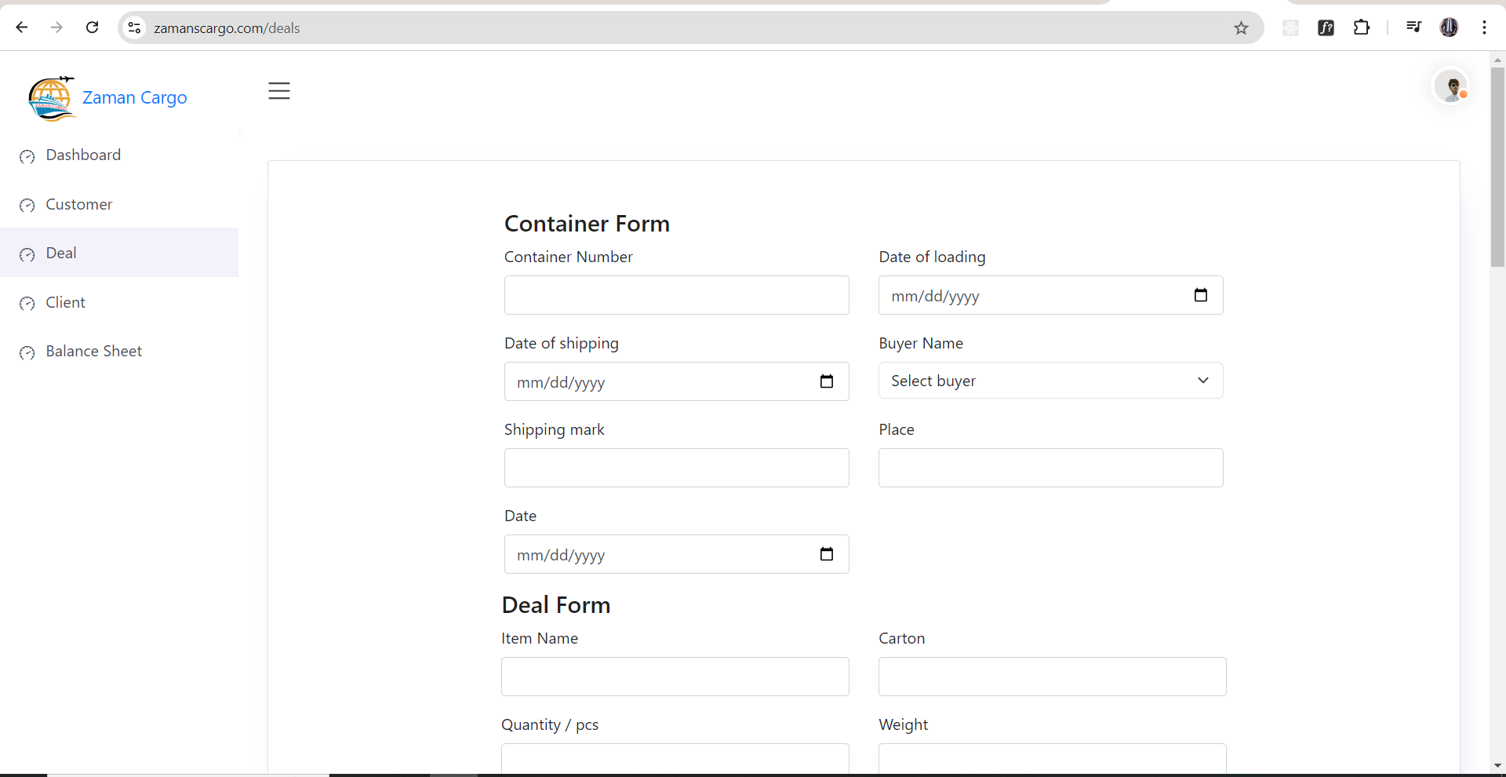

Therapy Dashboard:
Project Overview: CRM for Therapy Dashboard (Laravel, AJAX, Blade, Bootstrap, Vue.js)
This project involves building a comprehensive CRM system specifically designed for managing therapy clinics. The dashboard is built using Laravel, AJAX, Blade files, Bootstrap, and Vue.js, ensuring a modern, efficient, and user-friendly interface. Below is a detailed breakdown of the system's core features:
- Admin-Controlled Multi-Role Management:
The CRM allows the admin to manage multiple user roles, including but not limited to roles like admin, sub-admin, and other designated users. Each role comes with distinct permissions and access levels, enabling flexible control over the system's functionality. The admin can assign roles and ensure that users only access the sections relevant to their role.
- Dynamic Menus Based on User Roles:
The dashboard features dynamic menus that adapt based on the role of the logged-in user. This ensures that users only see the functions and data relevant to their responsibilities, enhancing user experience and minimizing clutter.
- Comprehensive Dashboard Management: The system enables seamless control and management of various critical components, including:
  - Inventory: Track and manage therapy-related equipment and supplies.
  - Employees: Admin can oversee employees, manage their profiles, and assign them to different therapy outlets.
  - Outlets: Manage multiple therapy centers or branches (outlets), with the ability to track and organize appointments and resources per outlet.
  - Appointments per Outlet: Admin can monitor appointments made at each outlet, ensuring smooth scheduling and resource allocation.
  - Customers: Keep detailed records of all clients, including their appointment history, personal details, and ongoing treatments.
  - Reviews: Collect and manage customer feedback, allowing admins to review and respond to customer ratings or reviews for improving services.
- Role-Based Access and Controls:
The admin role has full control over the entire system, while sub-admins and other roles can be granted specific access rights based on their needs. This ensures that sensitive data and administrative functions are securely handled by authorized users only.
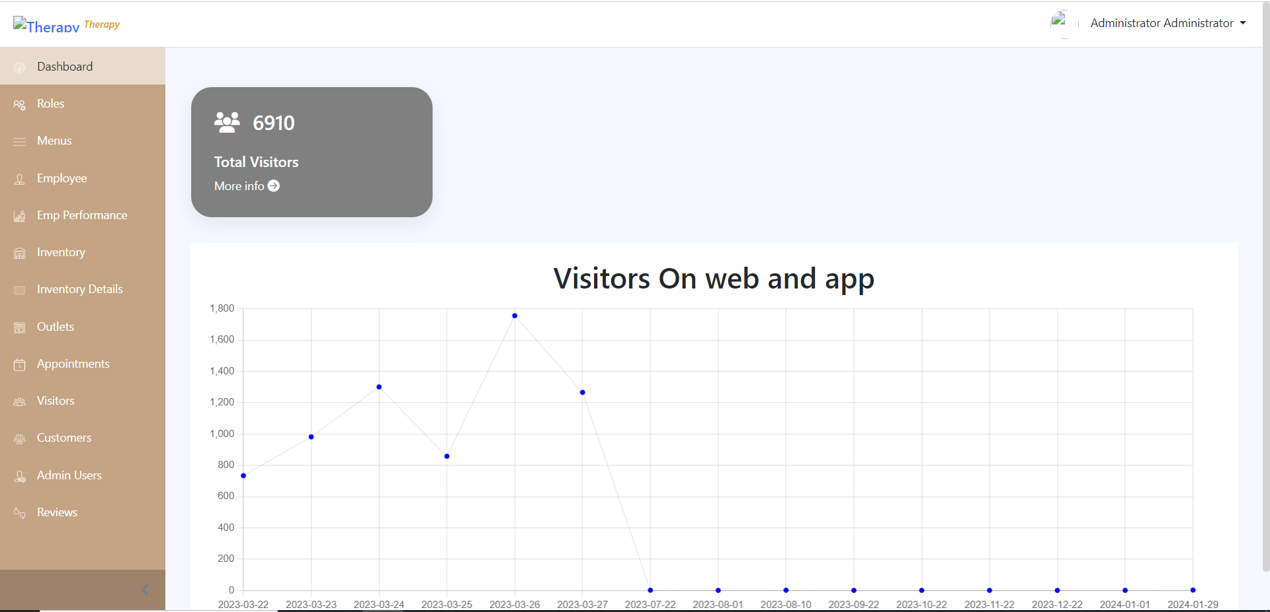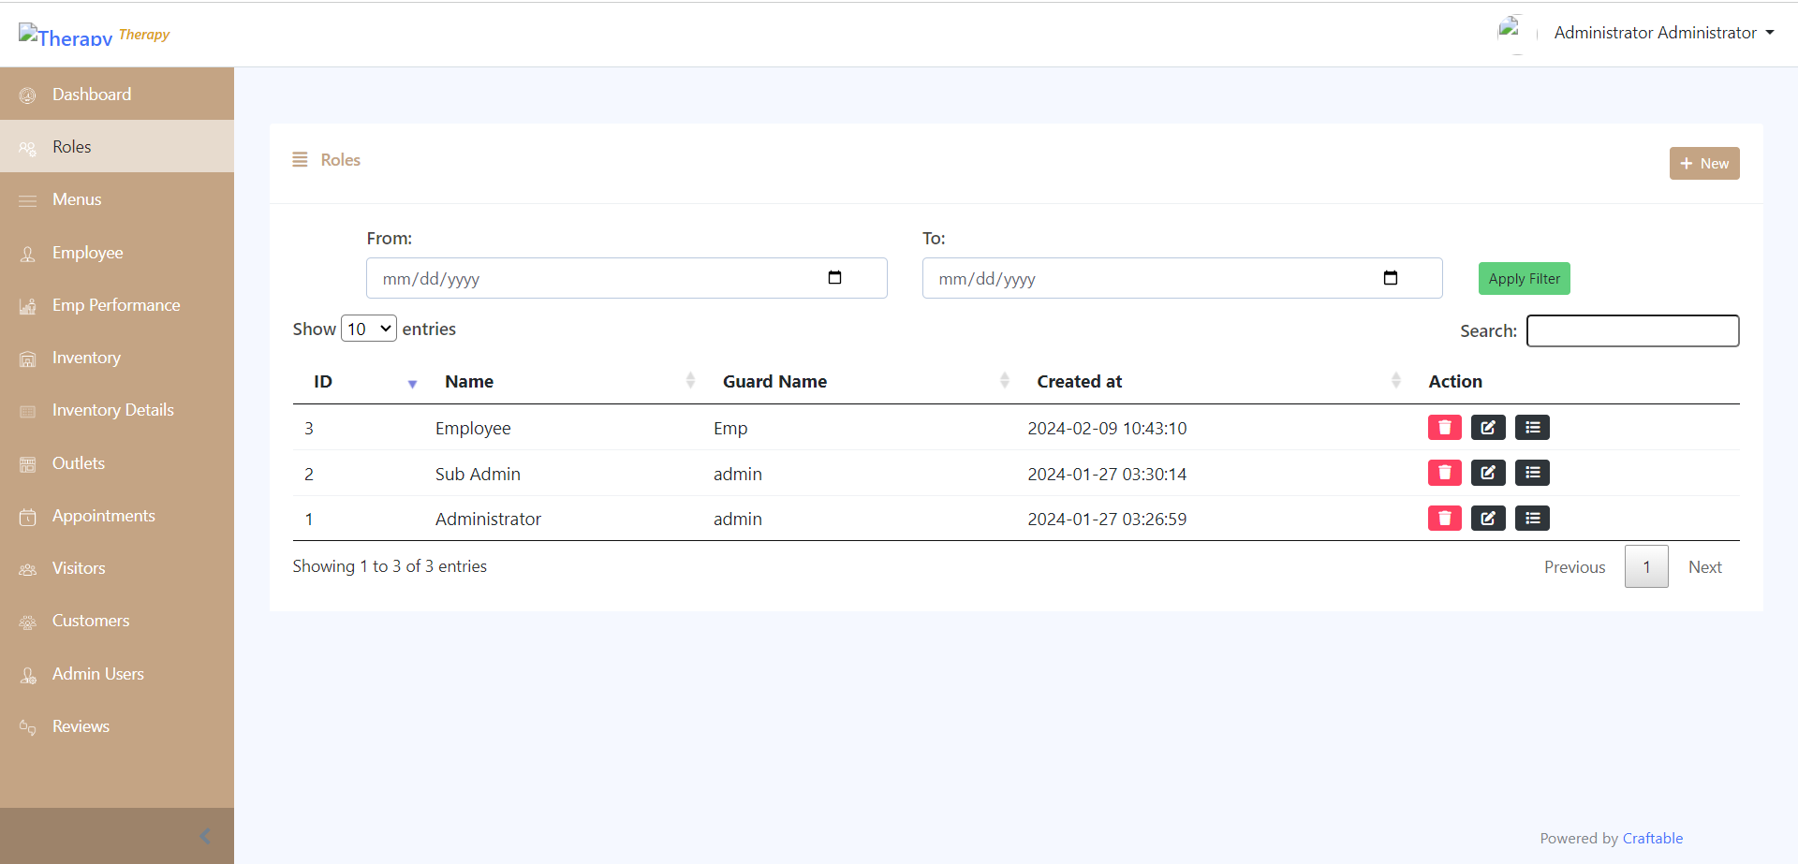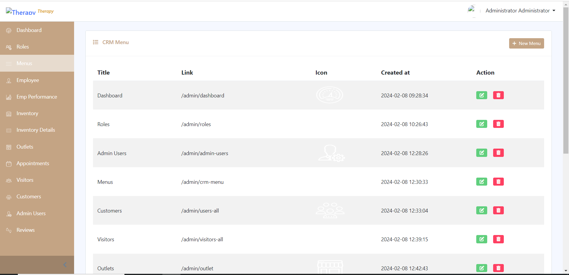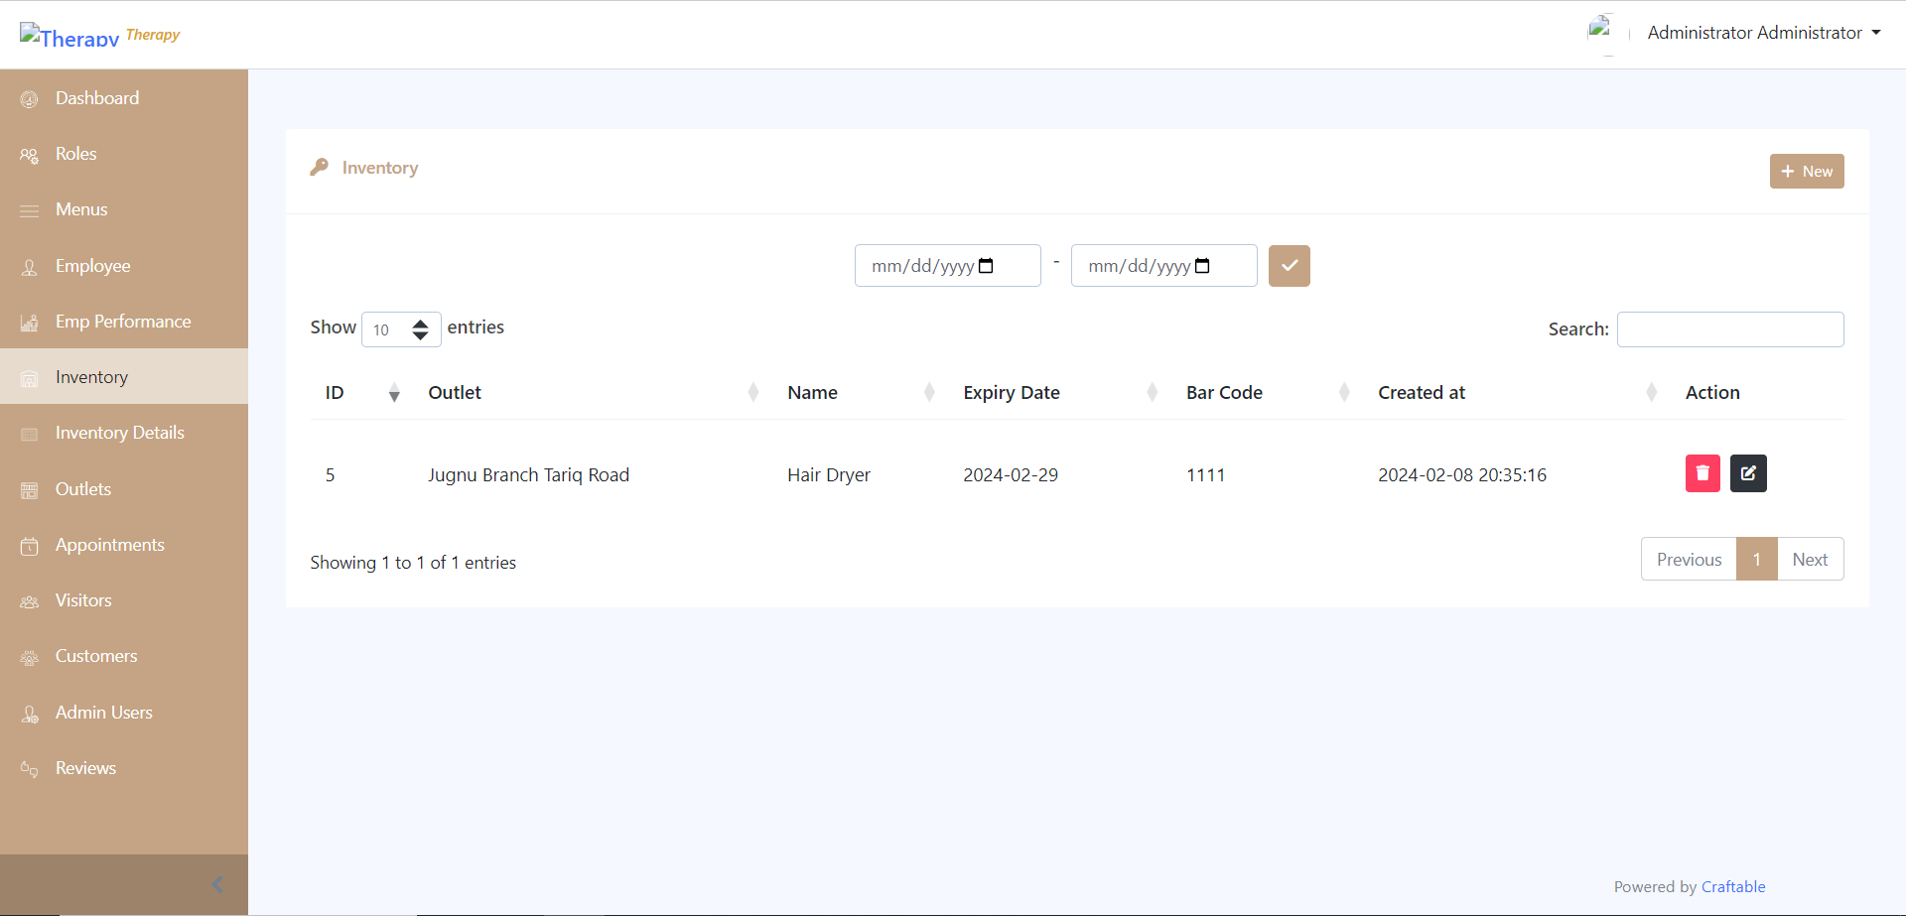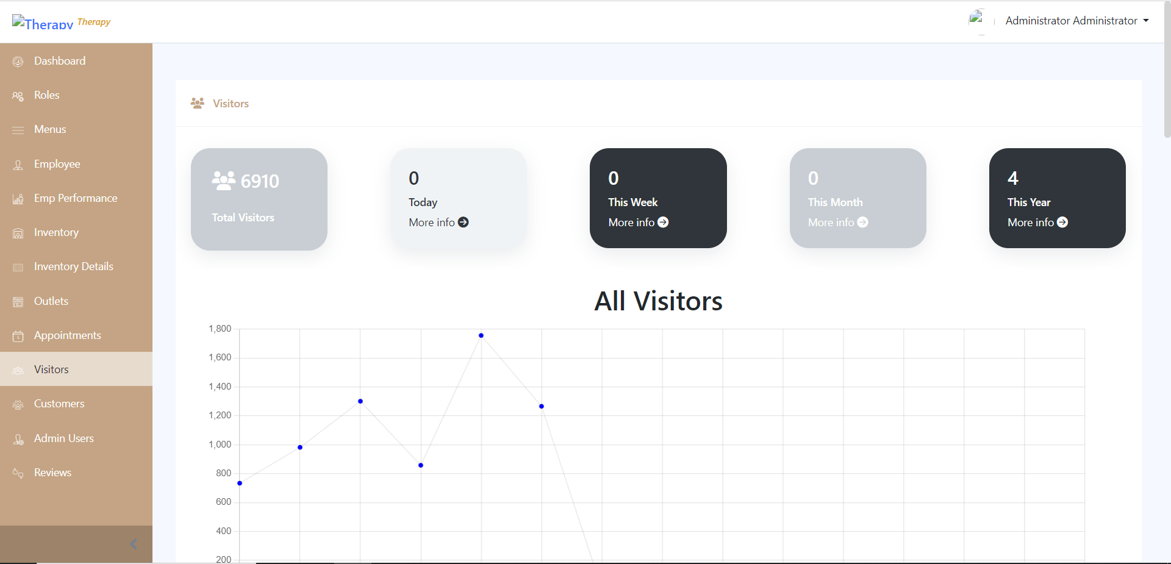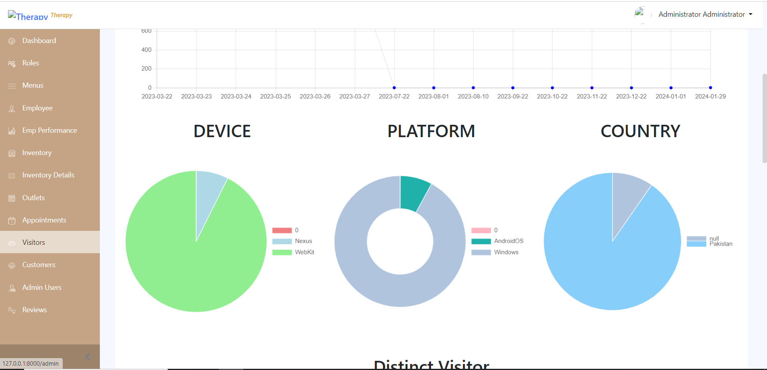

Star Tex:
The Star Tex Portal is a web-based system designed for managing inventory and purchase invoices related to gas deliveries. Built using PHP and MySQL, it allows multiple user roles (Super Admin, Sub Admin, Supplier, Driver) to manage various tasks such as:
- Tracking gas inventory levels at different locations.
- Managing deliveries and assigning drivers.
- Generating and managing customer invoices and payments.
- Monitoring gas orders and deliveries, with dynamic price calculations.
- Providing real-time sales analytics, payment tracking, and security permissions for all users.
This portal automates business operations, improving efficiency across inventory, delivery, and financial management.

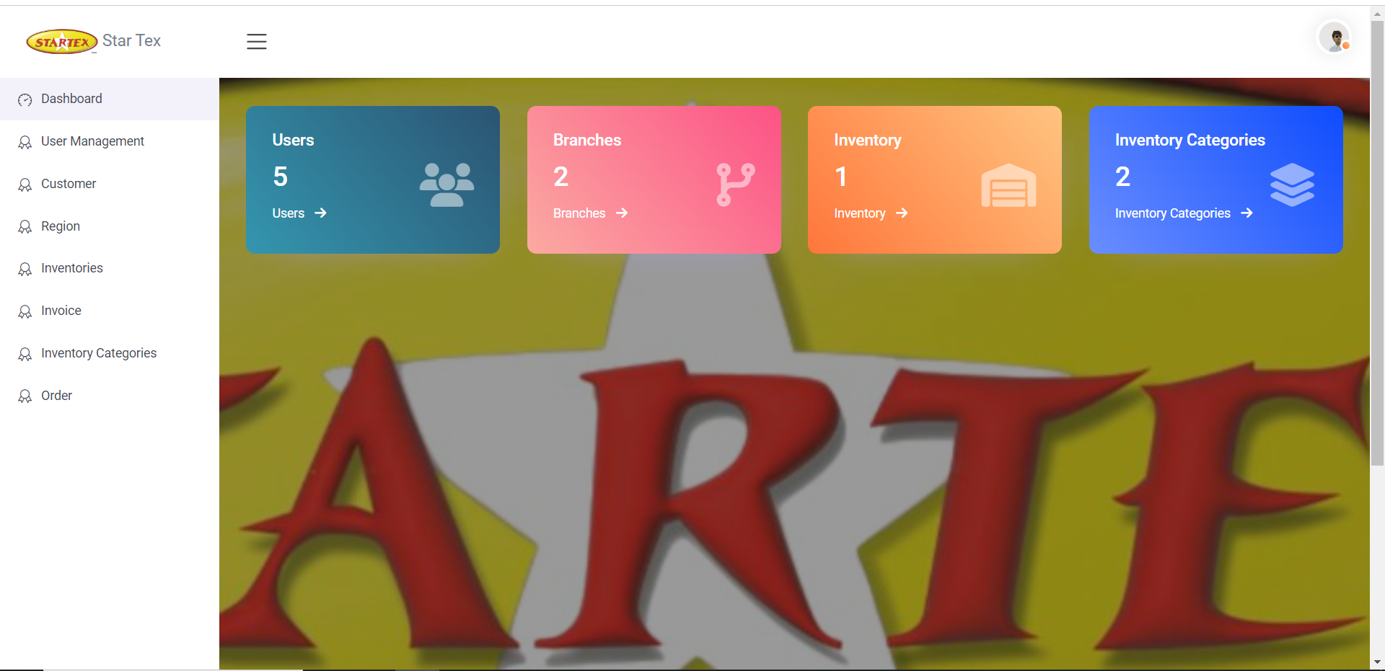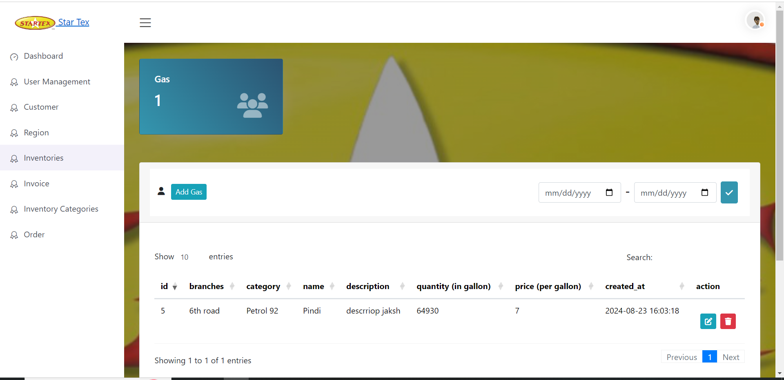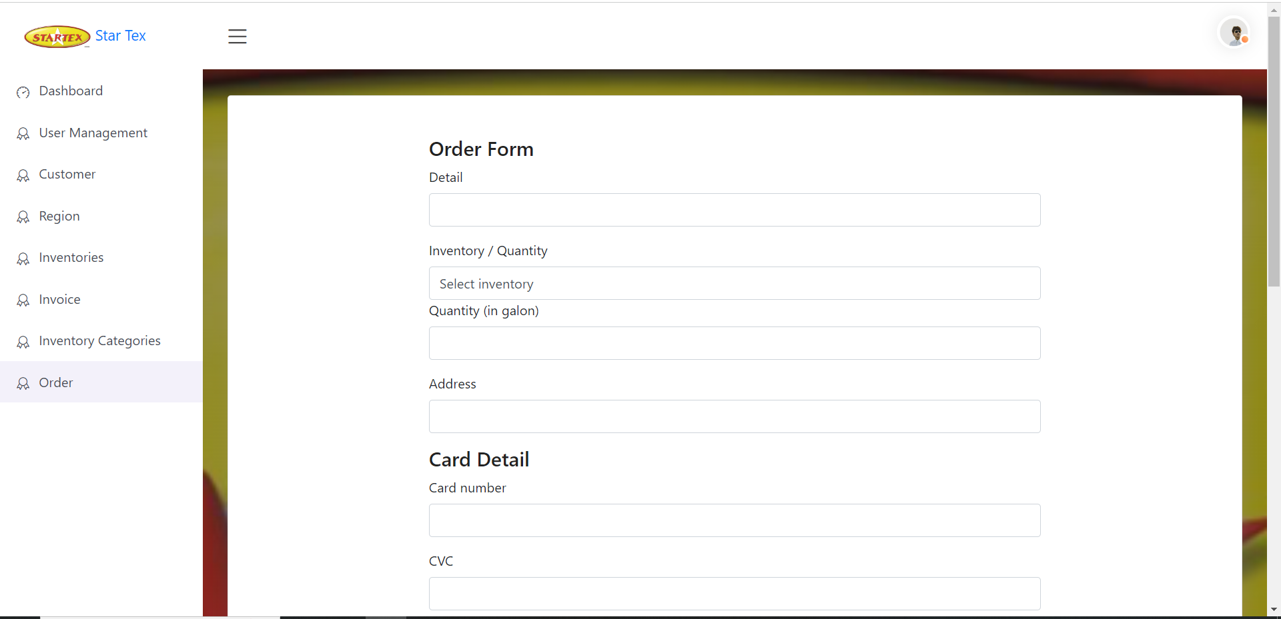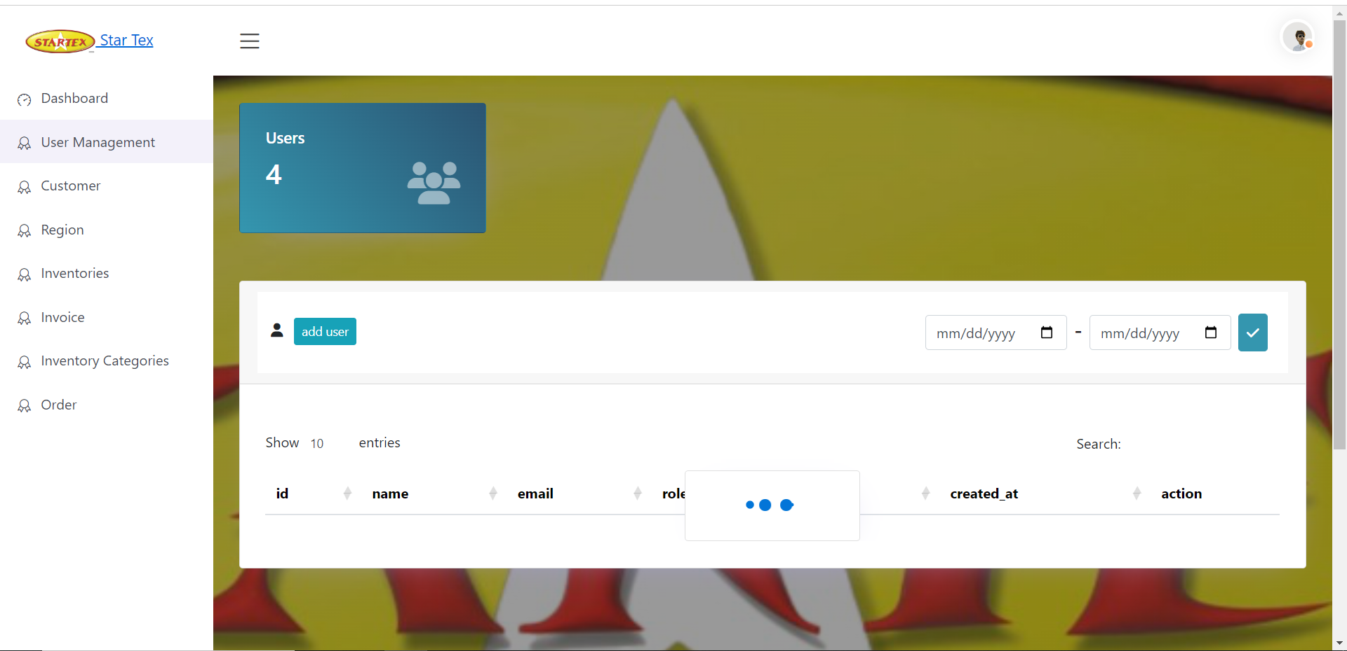

Internet Speed test
Project Overview: PHP-Based WiFi Speed Test (Ping, Jitter, Upload & Download Speeds)
This project involves developing a PHP-based system to measure WiFi speed, including key metrics such as ping, jitter, upload speed, and download speed. The system will:
- Ping & Jitter: Measure the latency and variation in response times for network requests.
- Upload & Download Speeds: Assess the speed at which data is uploaded to and downloaded from the server. The solution will use PHP for server-side operations, combined with client-side technologies (JavaScript, AJAX) to conduct real-time speed tests, providing users with accurate network performance insights.
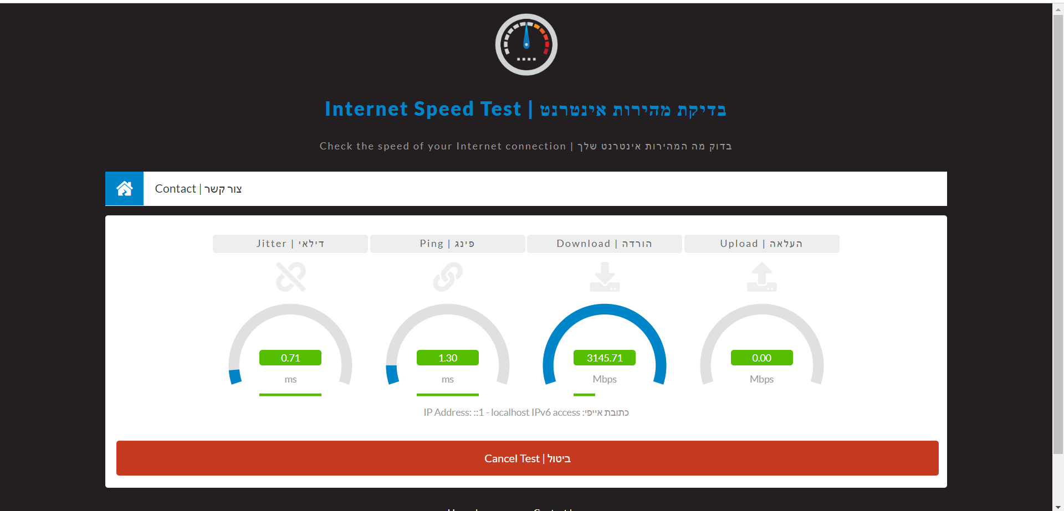

Jugnu Salon

Project Overview: Jugnu Salon Management System (HTML, CSS, Bootstrap, Laravel)
This project involves creating a complete salon management system called "Jugnu Salon." The frontend is built using HTML, CSS, JavaScript, and Bootstrap, while the backend is powered by Laravel. The system manages various functions, including customer management, employee handling, order processing, and reviews, all through a centralized dashboard. It also incorporates a branch management system, allowing separate branches to operate independently. Data is stored securely using MySQL, ensuring smooth and efficient operations across all branches.
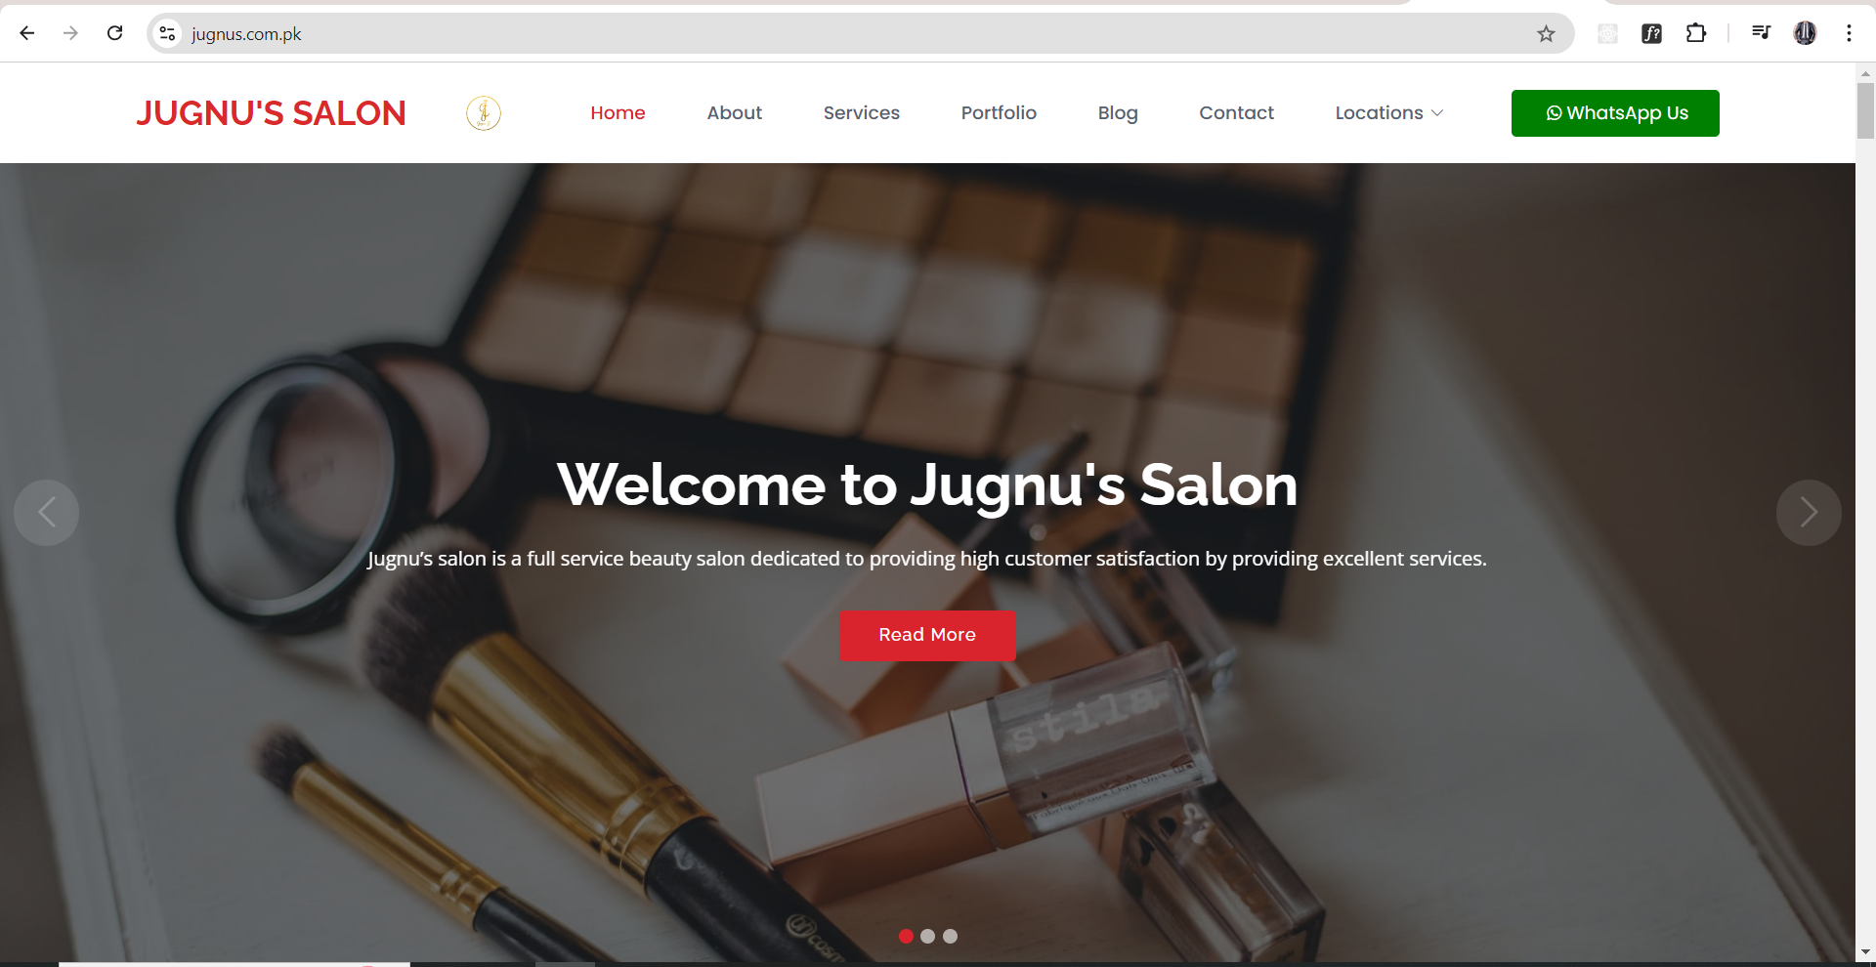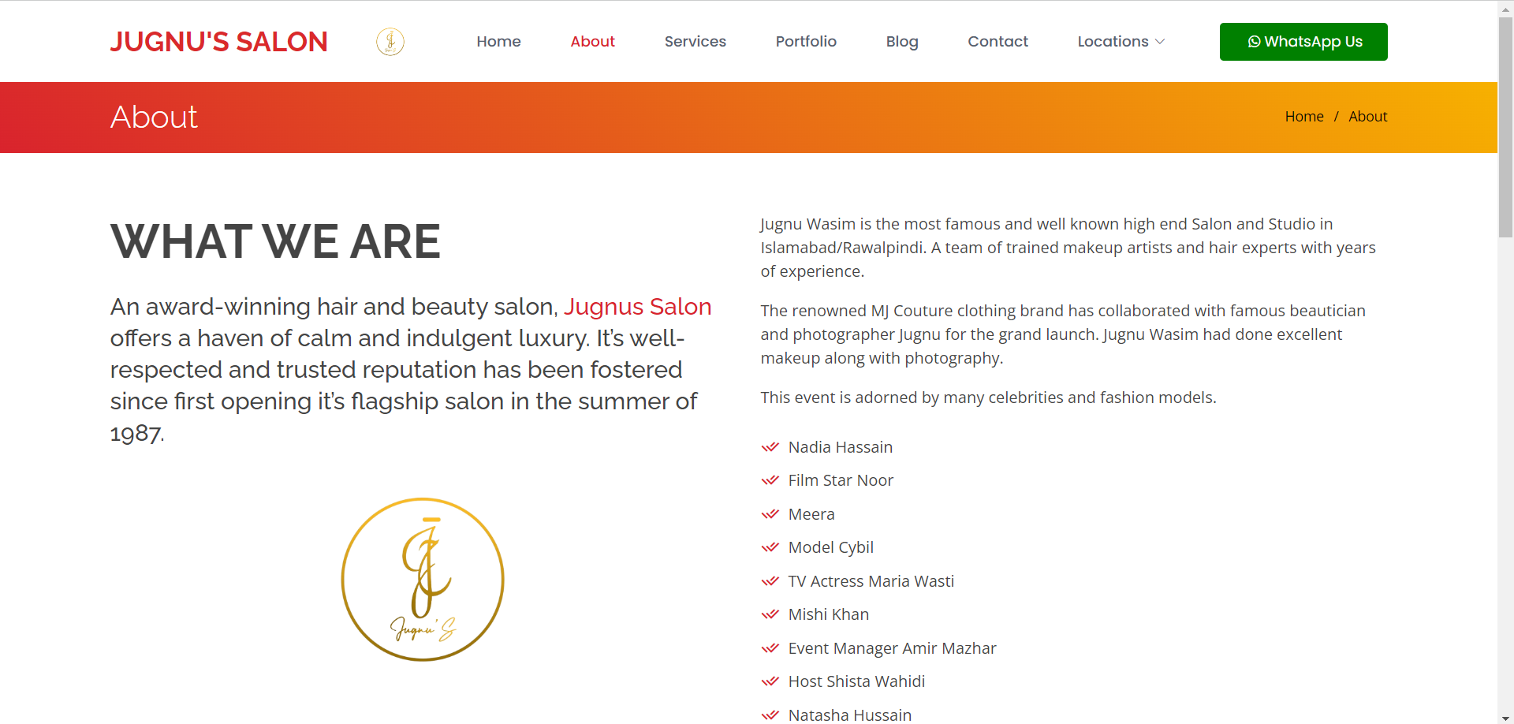
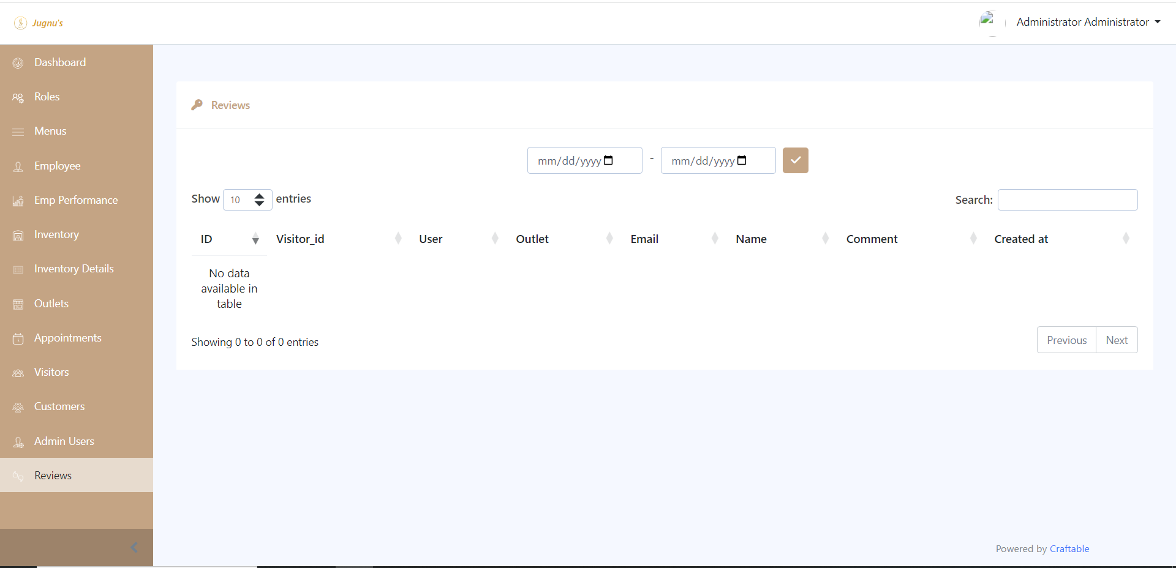

SAFE EYE:
Project Overview: Safe Eye Jewelry Management System (Laravel, MySQL, Blade, Bootstrap)
Safe Eye is a comprehensive jewelry management system designed for a jewelry brand. The backend is built using Laravel, MySQL, Blade, and Bootstrap. The system offers role-based dashboards for different user types, such as admin and sellers, providing tailored permissions for each role. Key features include:
- Inventory Management: Manage and track all jewelry inventory, including automatic zakat calculations for each item.
- Role-Based Access: Multiple dashboards for users with varying permissions (admin, seller, etc.).
- User Attendance System: Track user login, break, and logout times, ensuring accurate attendance monitoring.
This system is built for efficient inventory control and role-based operations, tailored to meet the needs of a jewelry business.
Front end is in the react js .
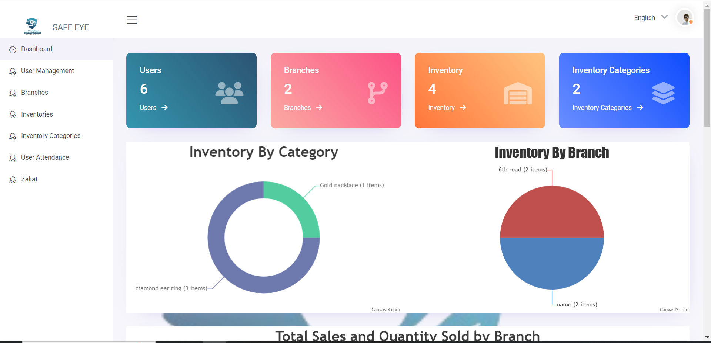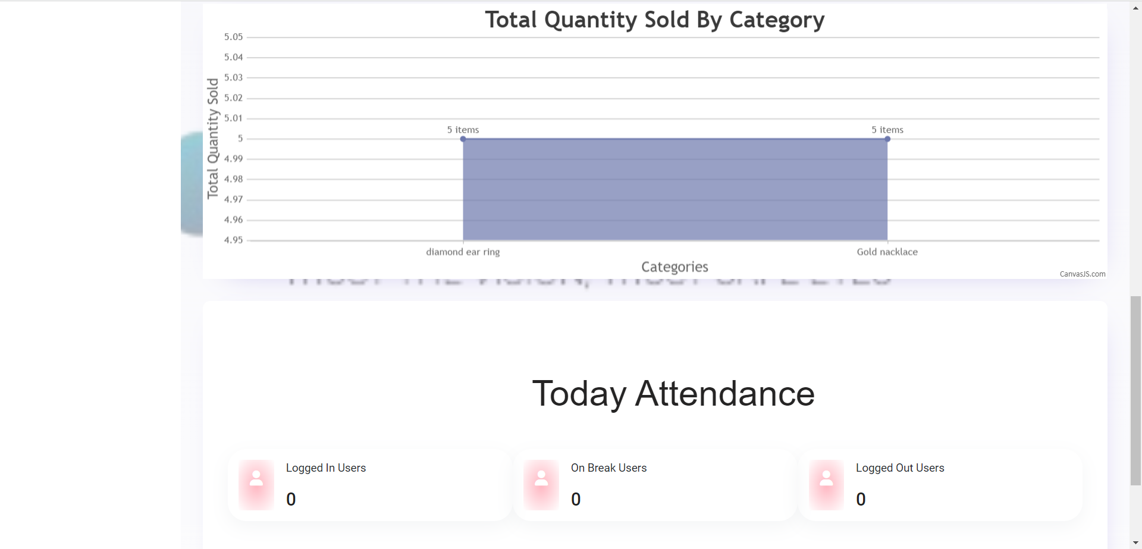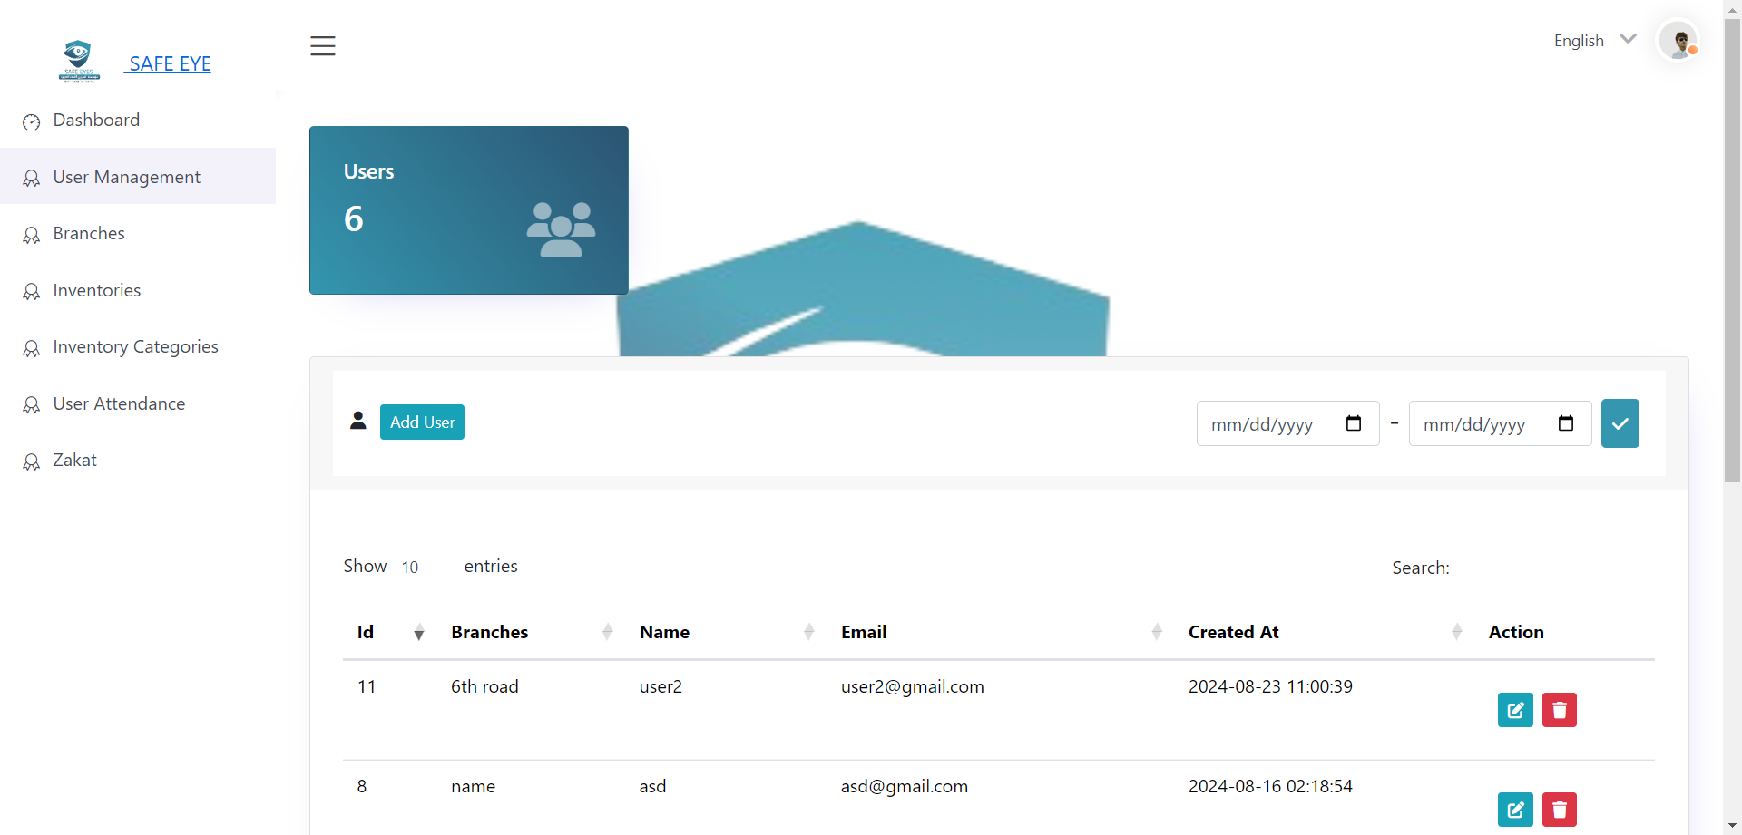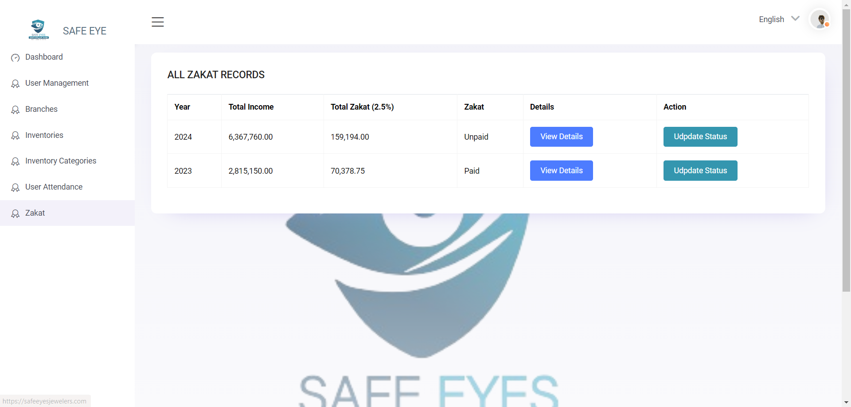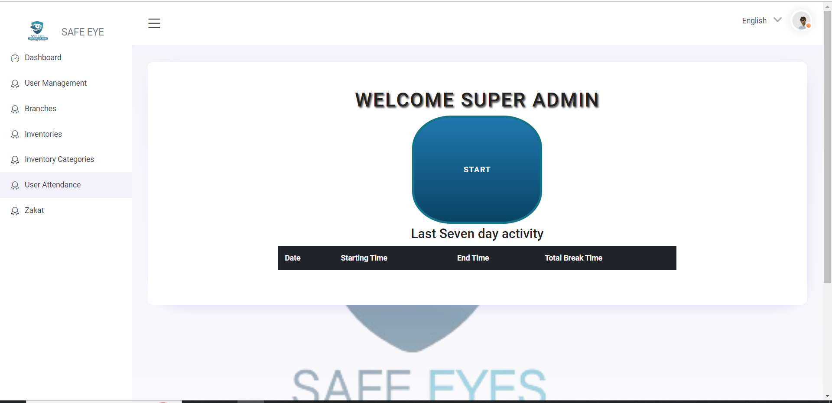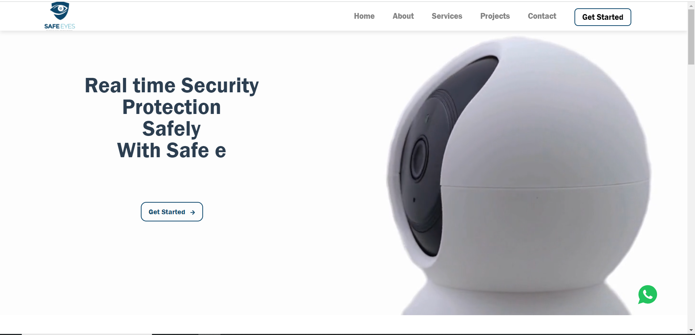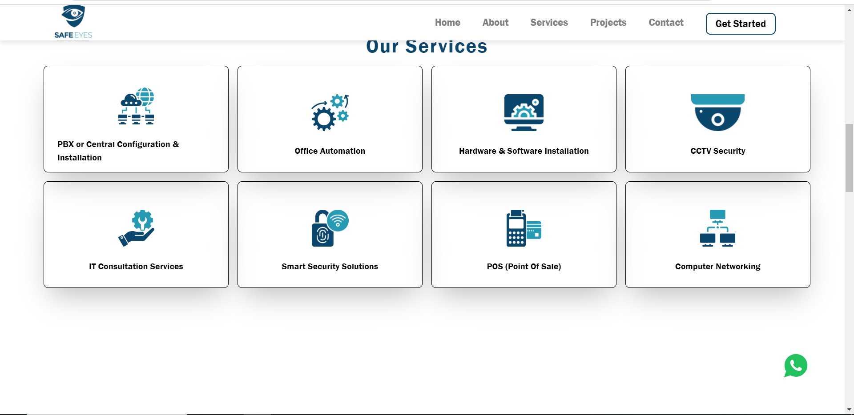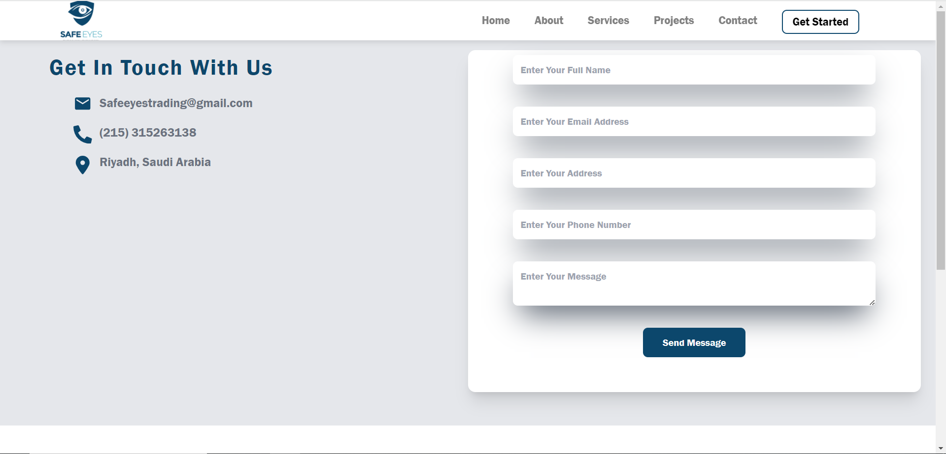

Lost and found
Memory updated
Here’s a project description for your lost and found system for Upwork:

Project Overview: Lost and Found System (Laravel)
This project is a web-based lost and found system built in Laravel. It allows users to post about lost items by specifying details such as the item, location, and area where it was lost. If another user finds the item in the same area, the system matches the lost and found entries, enabling the users to communicate via a built-in chat feature. Once the item is returned, the finder can receive credit for their effort.
Key features include:
- Location-Based Item Matching: Automatically matches lost and found items based on location and description.
- User Chat System: Enables seamless communication between the person who lost the item and the one who found it.
- Credit System: Acknowledges and rewards users who successfully return found items.
This system provides an efficient platform for reuniting lost items with their owners, fostering community support.

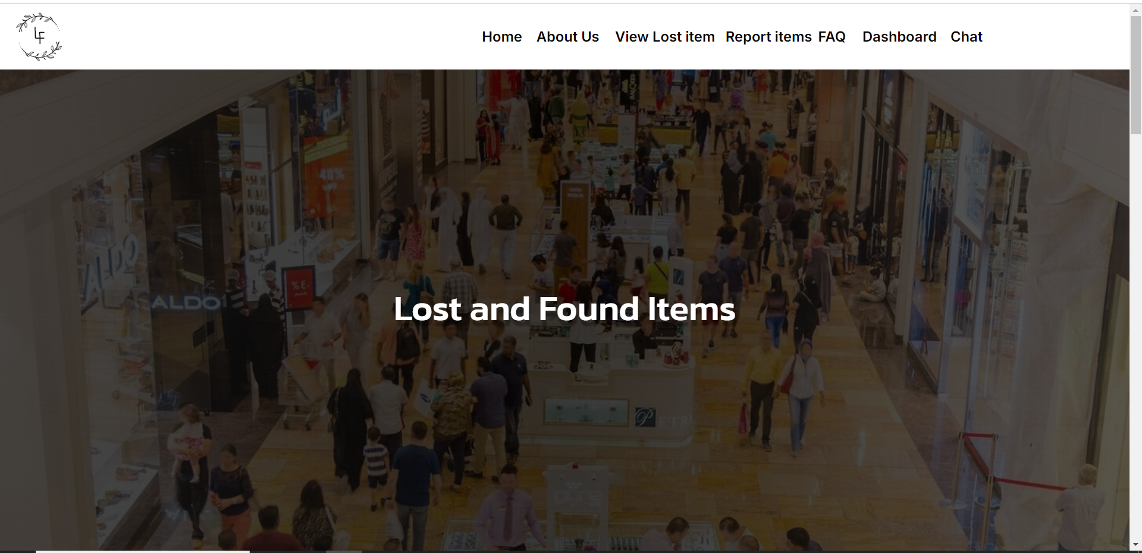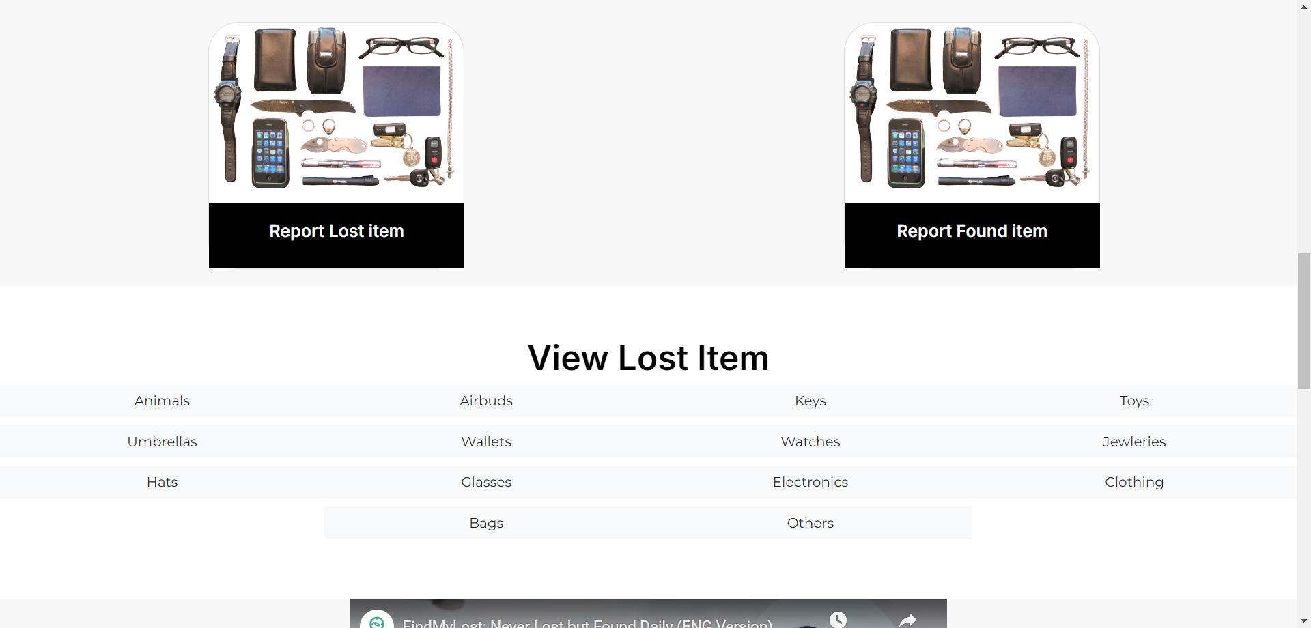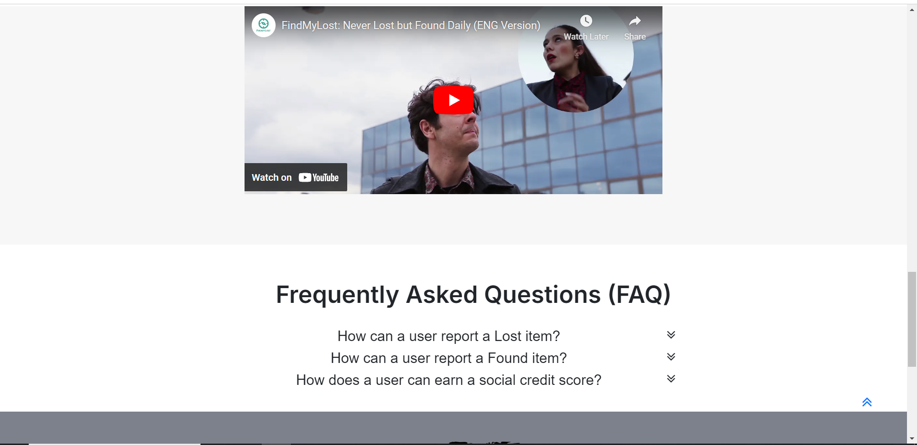

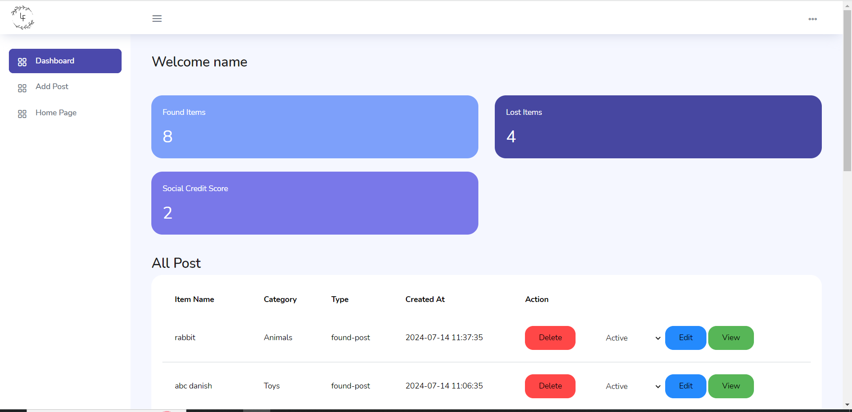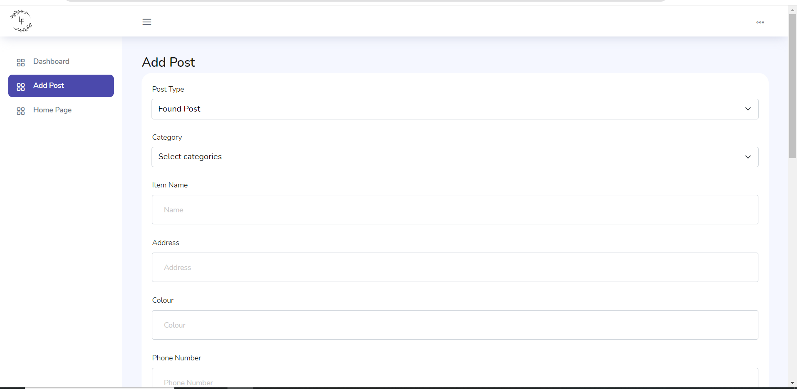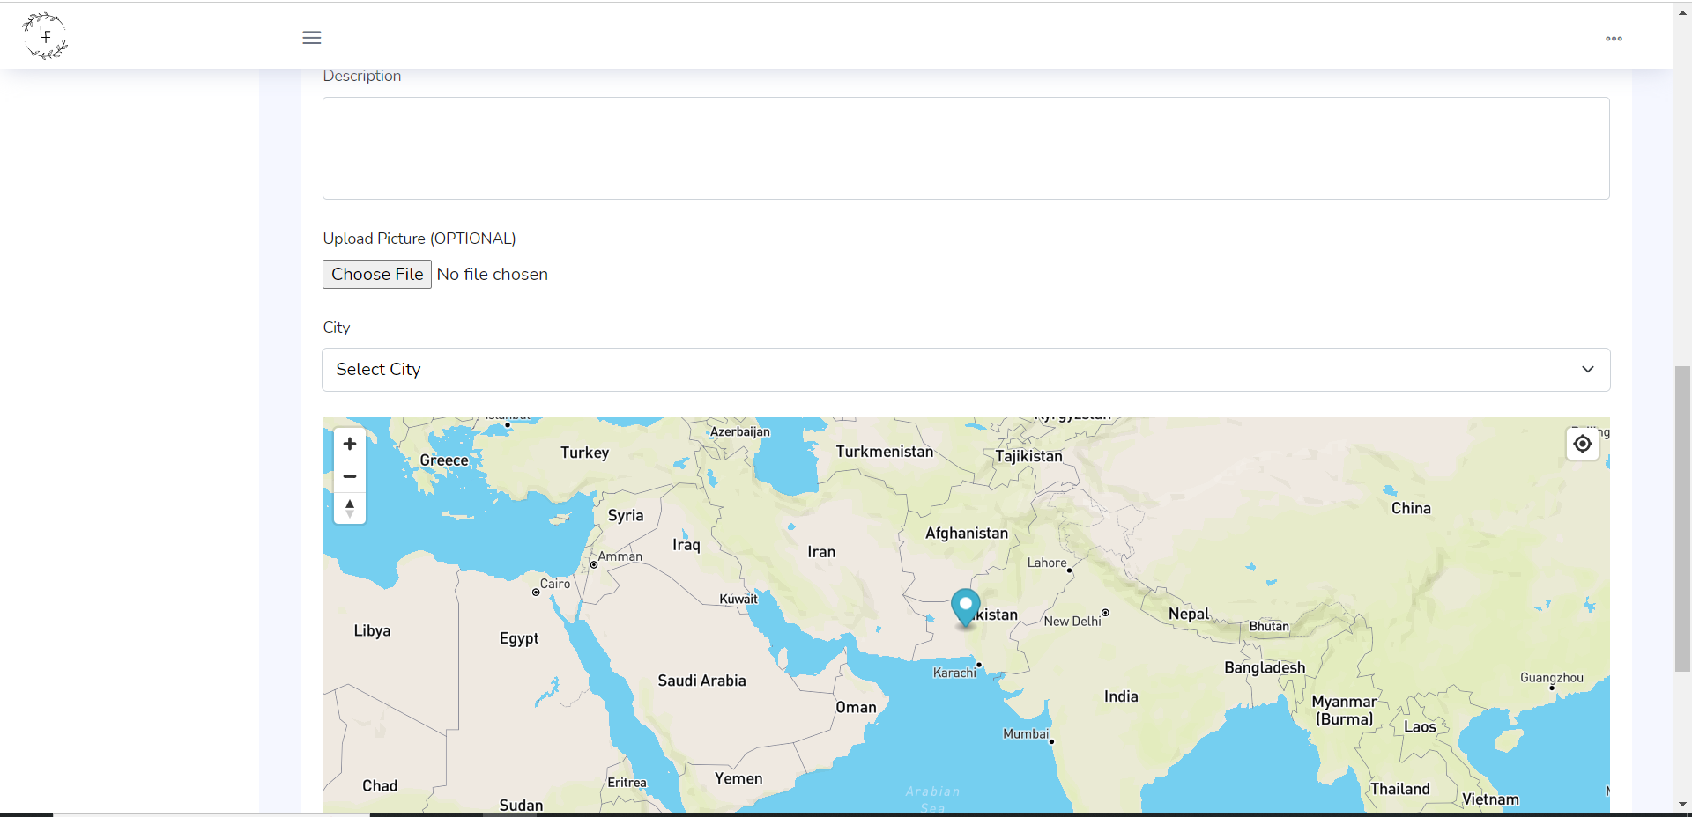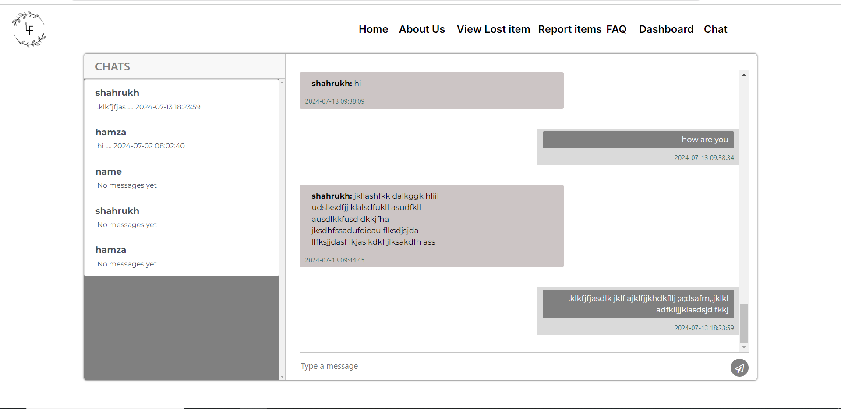

Lead Selling
This project is a lead selling system developed in Laravel, designed to streamline the process of managing and selling leads. The system enables admins to add leads to the platform, which are then assigned to sub-admins. Sub-admins can assign the same lead to multiple buyers, facilitating efficient lead distribution and maximizing sales opportunities.
Key features include:
- Admin and Sub-Admin Roles: Admins can manage the overall lead management process, while sub-admins focus on assigning leads to buyers.
- Multi-User Lead Assignment: The same lead can be assigned to multiple users, enhancing the potential for sales.
- Lead Management Dashboard: A user-friendly dashboard to track leads, assignments, and sales performance.
This system provides a robust solution for managing lead sales, allowing for flexibility and effective resource allocation.
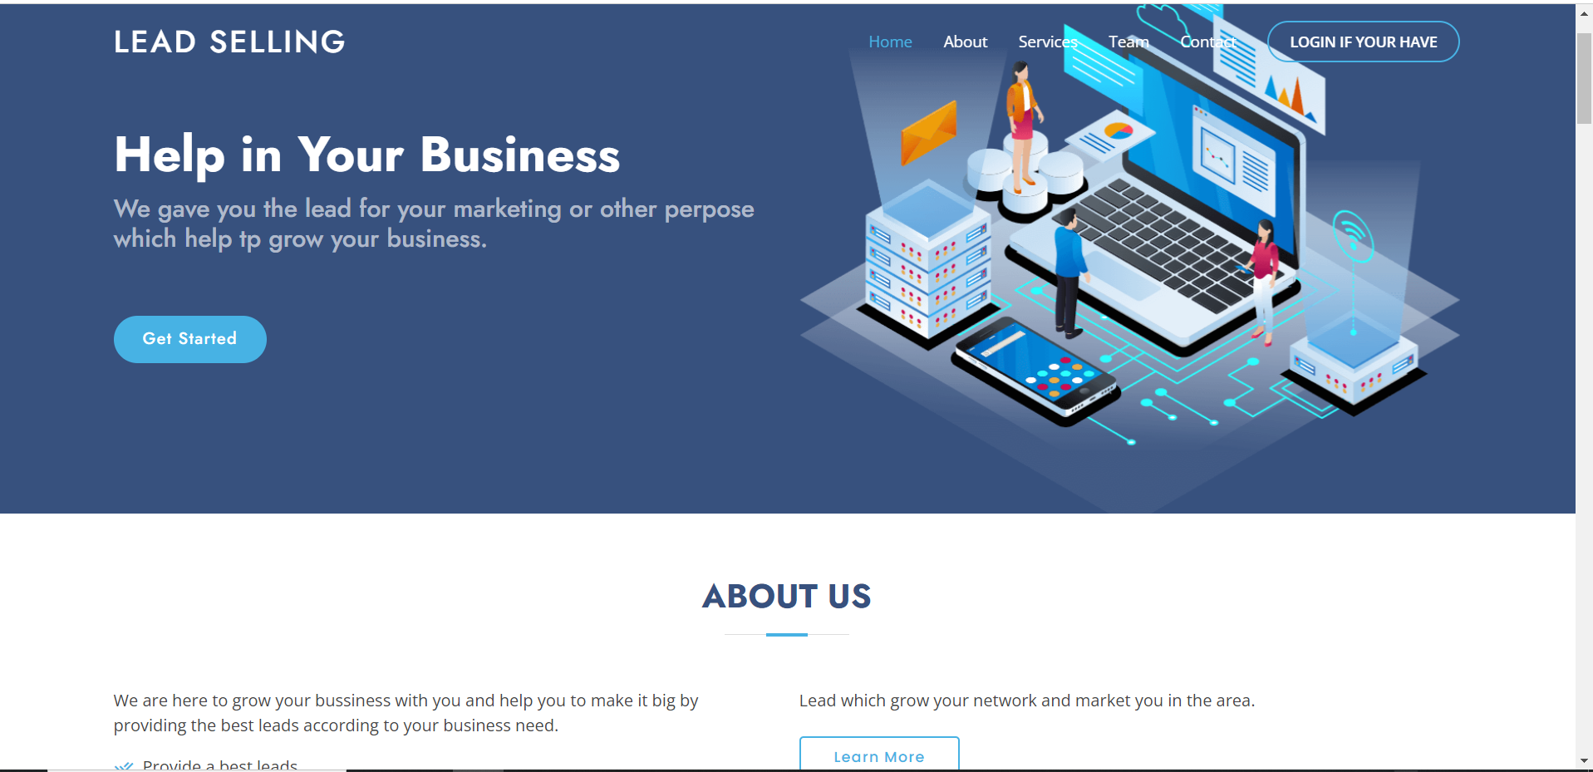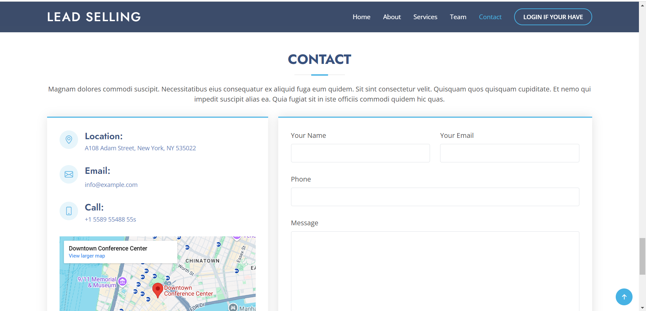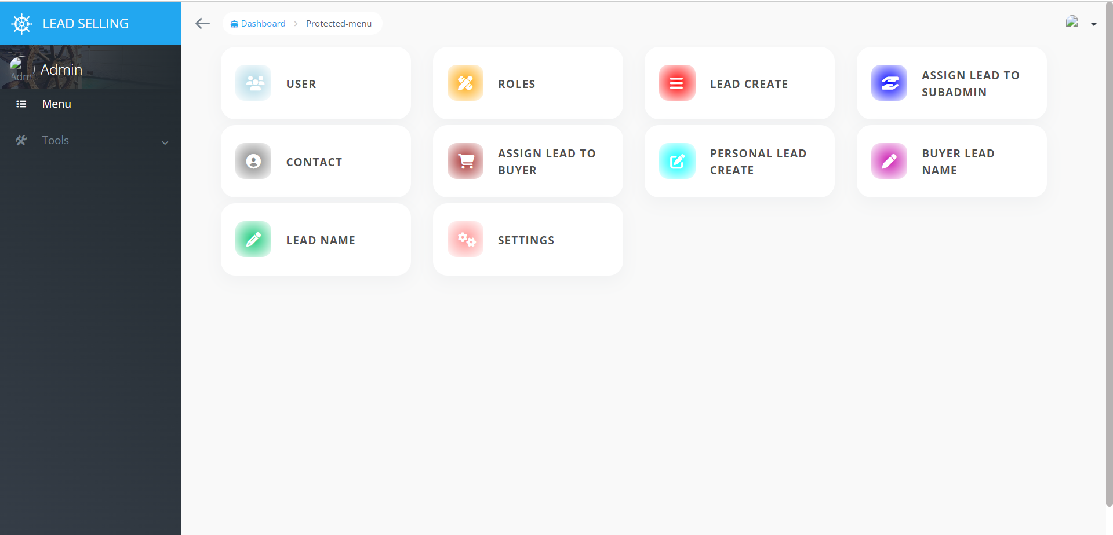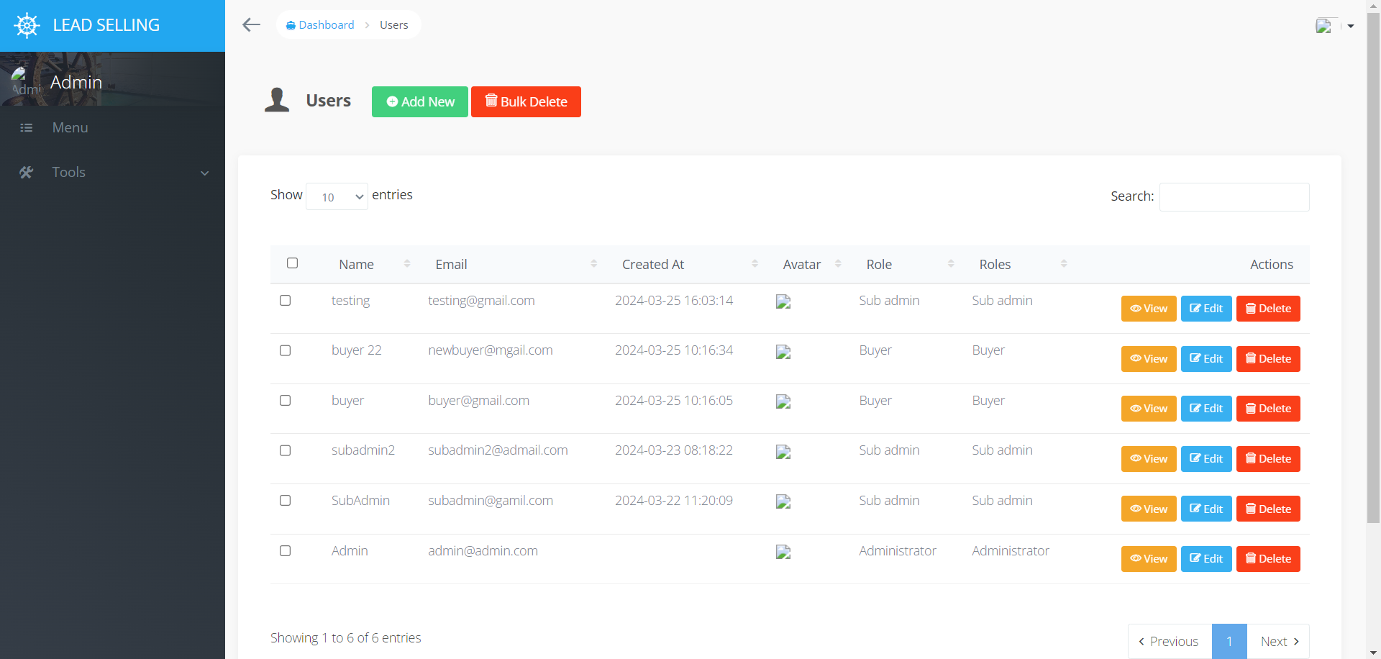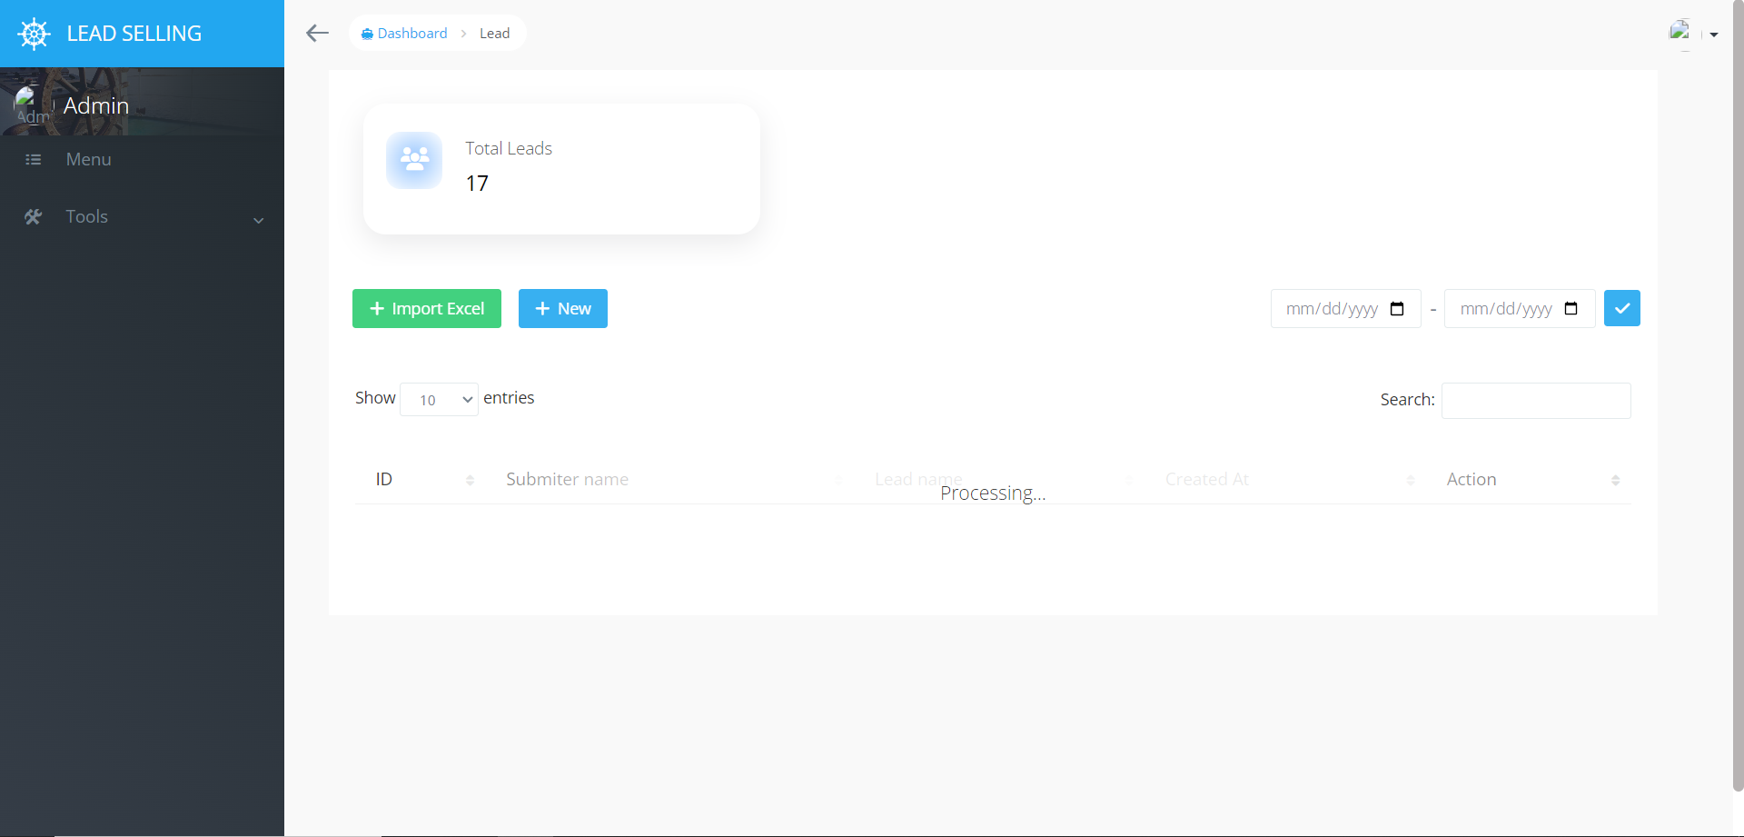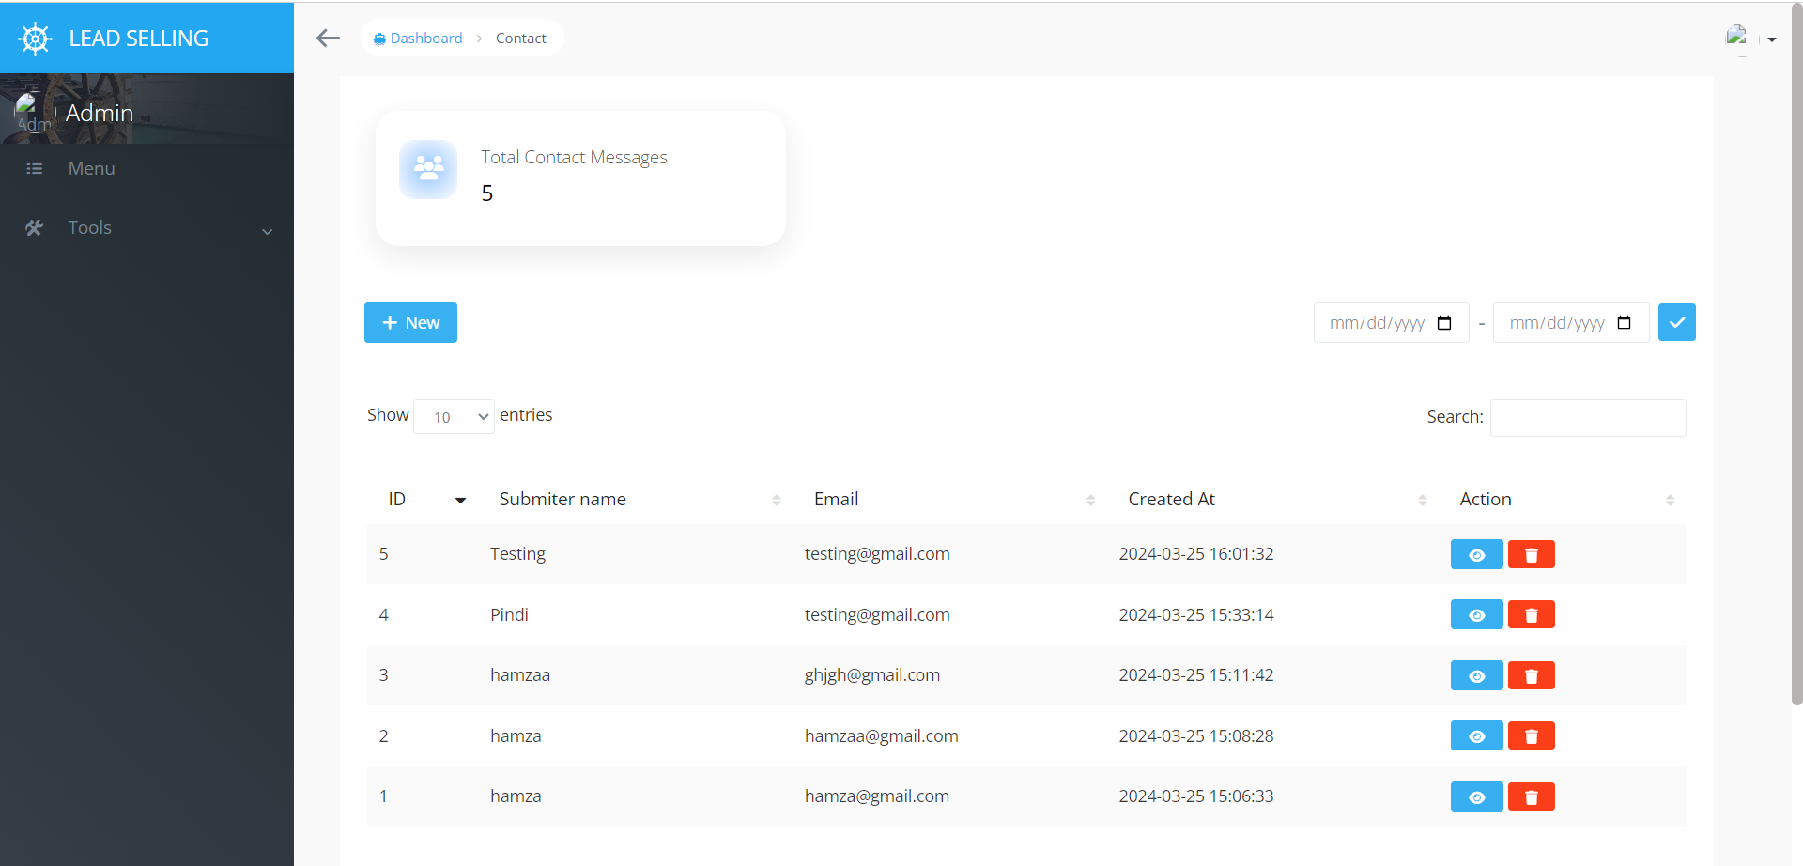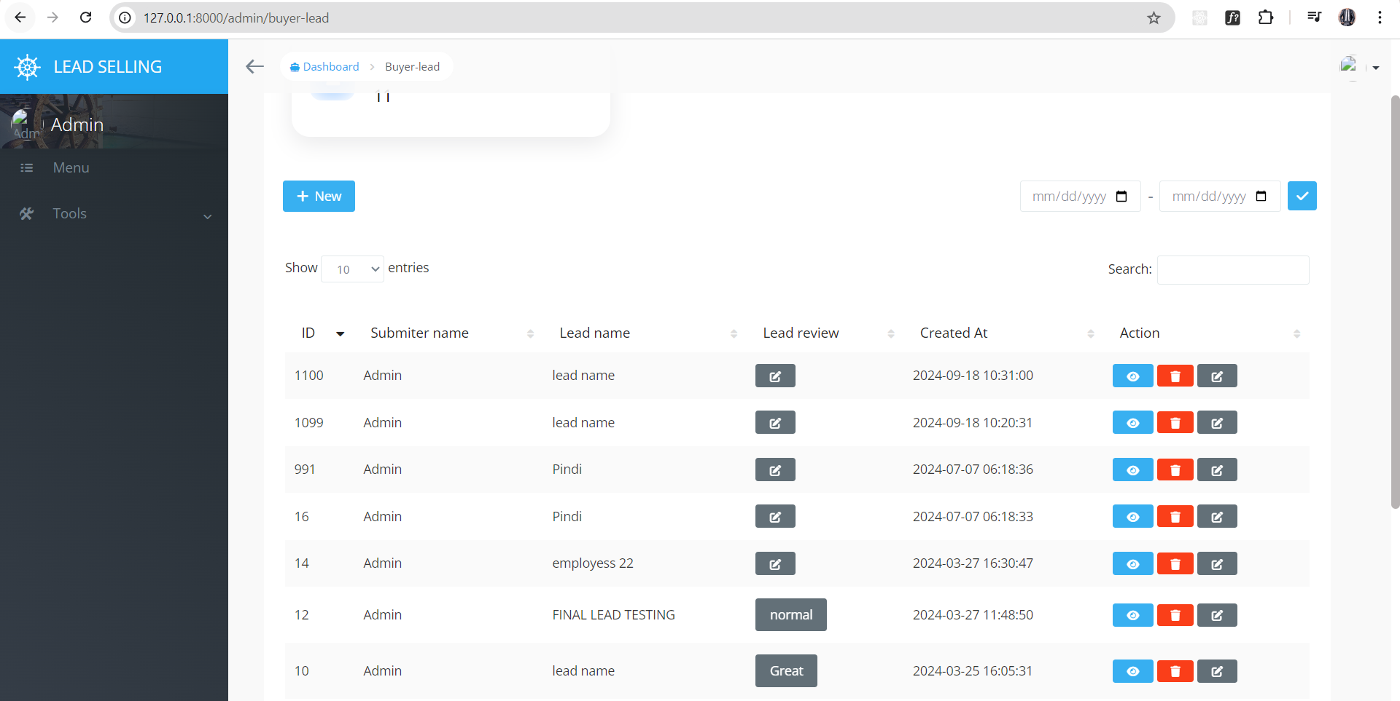

Event management
Project Overview: Event Management System (Laravel Backend with React.js Frontend)
This project involves developing an event management system with a Laravel backend and APIs for a React.js frontend. The system is designed to streamline the management of events by providing the following key features:
- Admin Dashboard: Admins can efficiently manage event venues, including adding and updating locations for events.
- Order Management: The system handles orders by allowing admins to specify dishes and guest quantities, ensuring accurate event planning.
- Contact Form: A built-in contact form facilitates communication between users and the admin, enhancing user support and engagement.
This solution provides a comprehensive backend for managing event logistics while leveraging the responsiveness and interactivity of a React.js frontend.
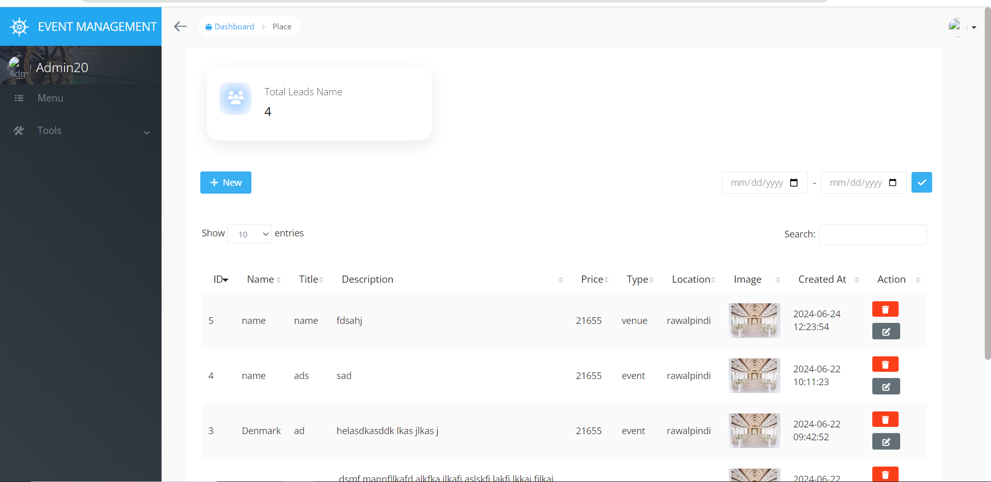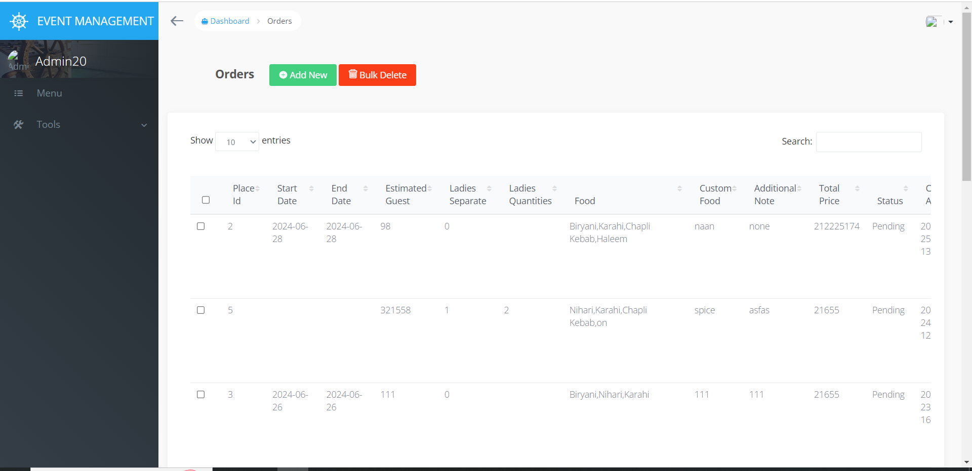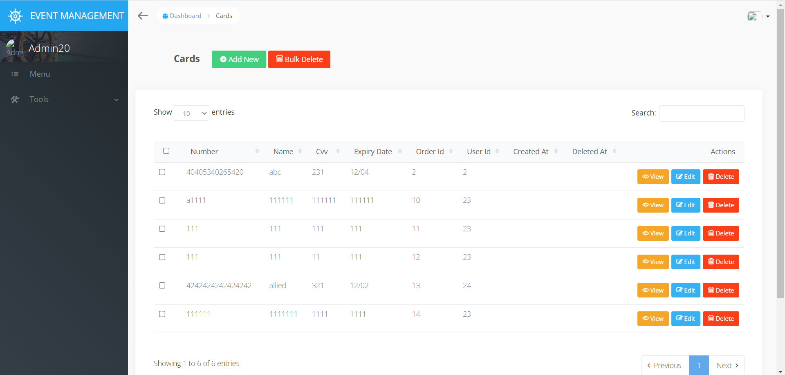

Foodie baba
Foobie baba website is in the mern js, it is simple fastfood website
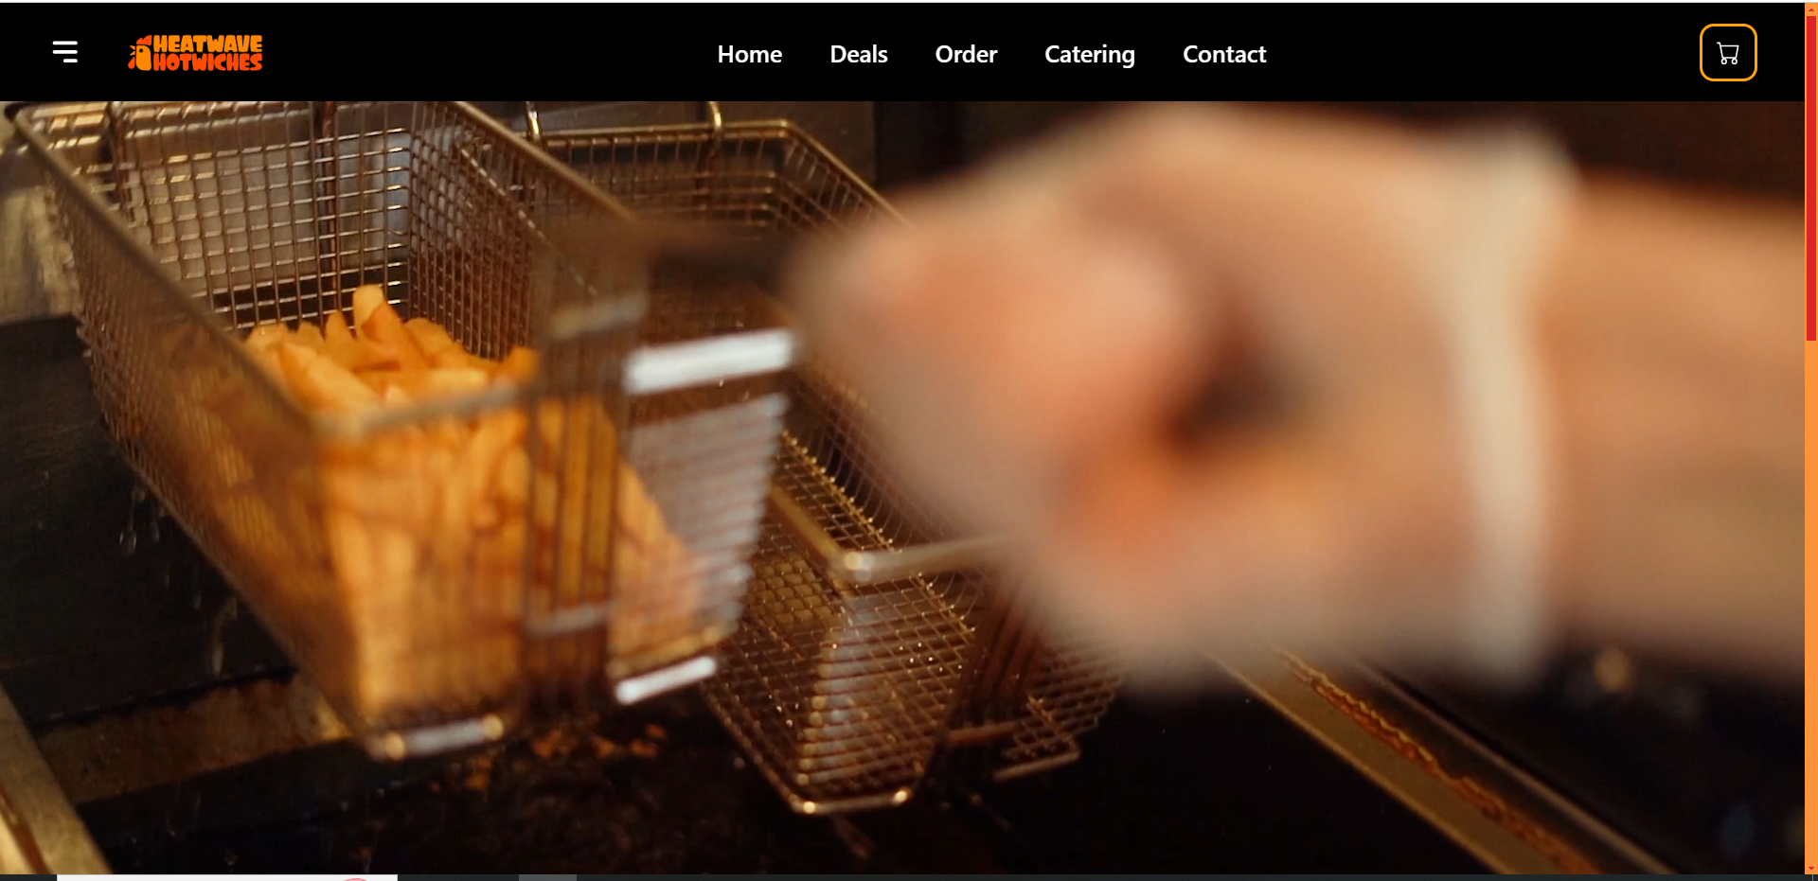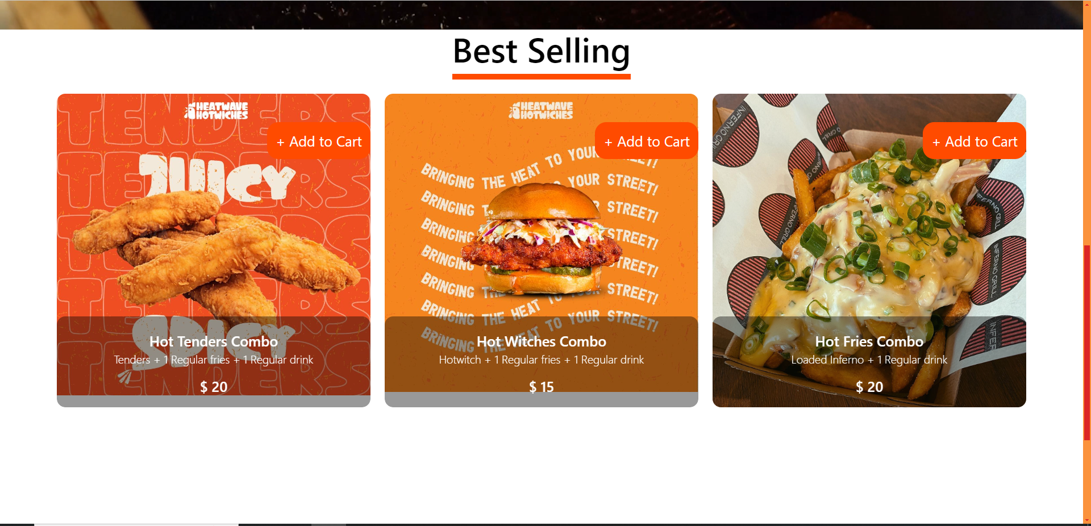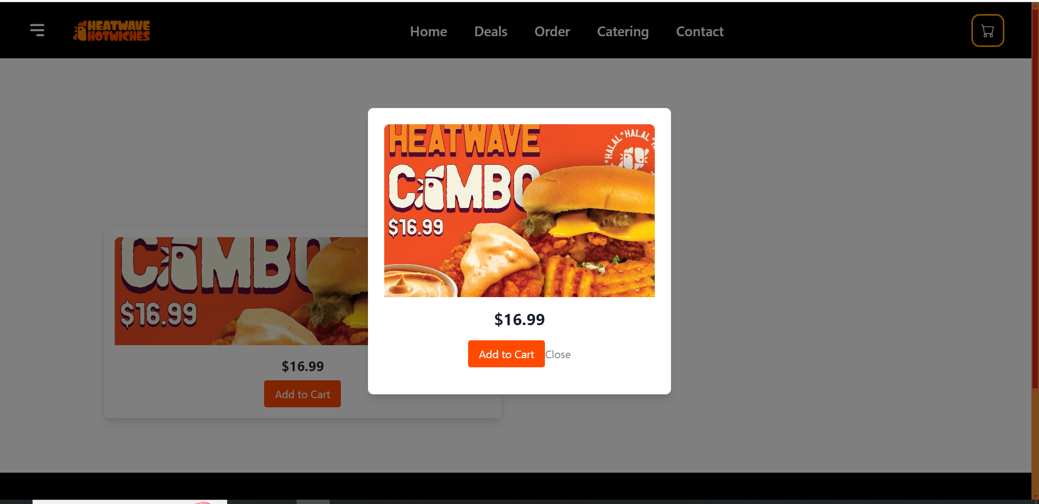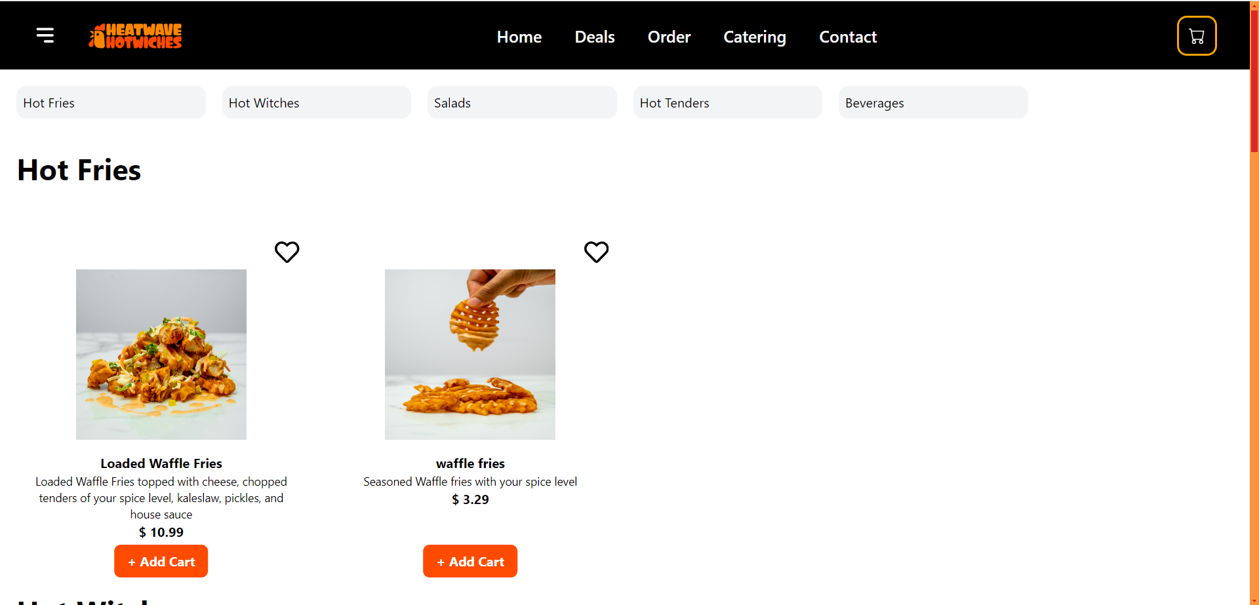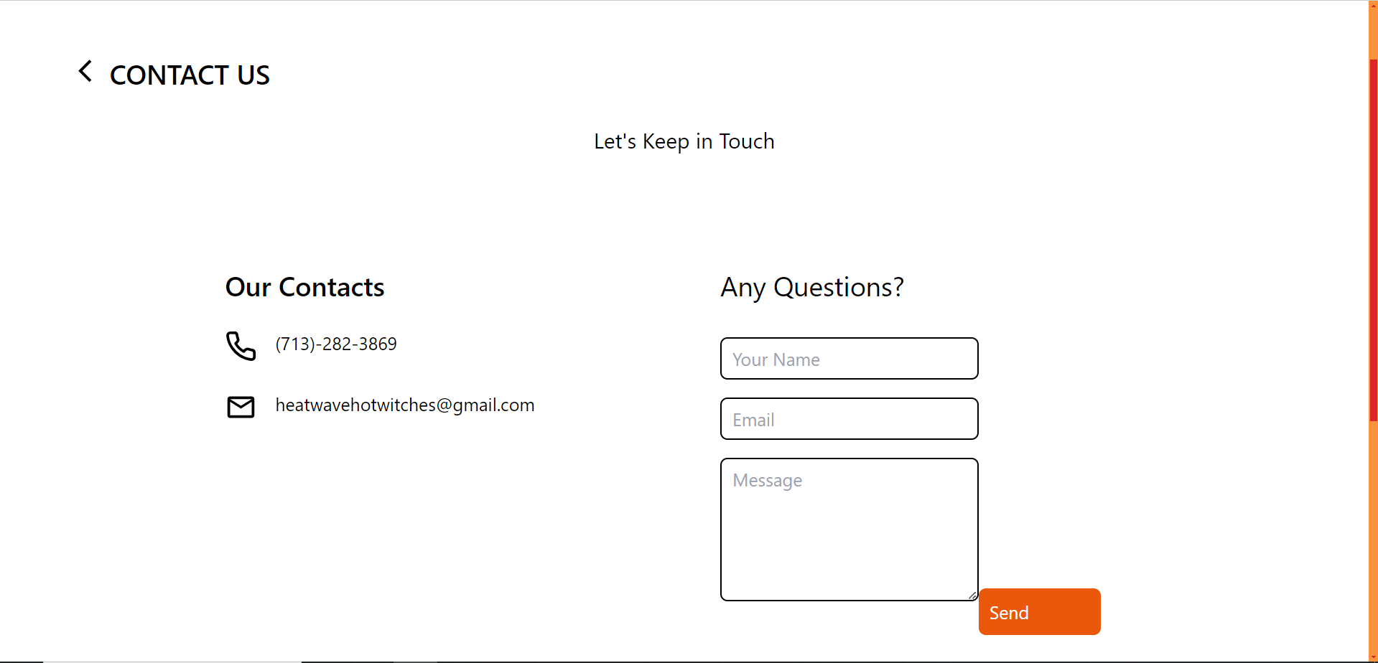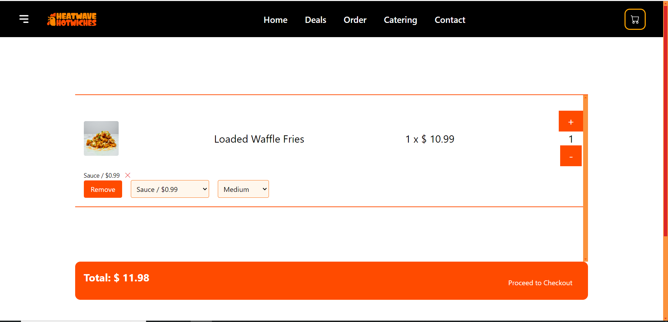

Tiffin:

Project Overview: Tiffin Delivery Website (Next.js)
This project involves developing a Tiffin delivery website using Next.js, designed to facilitate seamless booking and delivery of tiffin services. Key features of the platform include:
- Tiffin Booking: Users can easily book tiffins within a 5 km radius from their location, ensuring convenient access to meals.
- Menu Selection: Customers can browse and select from a variety of menu options tailored to their preferences.
- Contact Form: A contact form allows users to reach out for inquiries or support, enhancing customer service.
- Admin Panel: The admin panel provides comprehensive oversight of all bookings and customer details, enabling efficient management of orders and operations.
This solution leverages the power of Next.js to deliver a fast, responsive, and user-friendly experience, making it easier for customers to enjoy quality tiffin services.
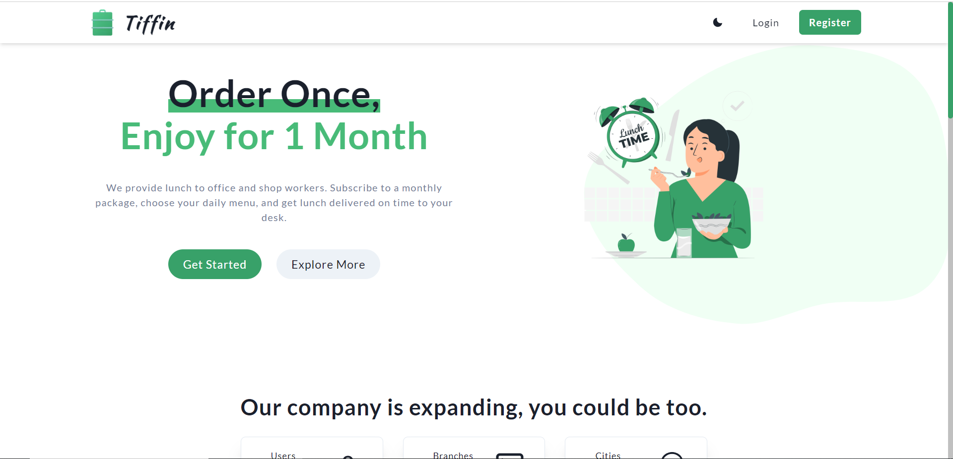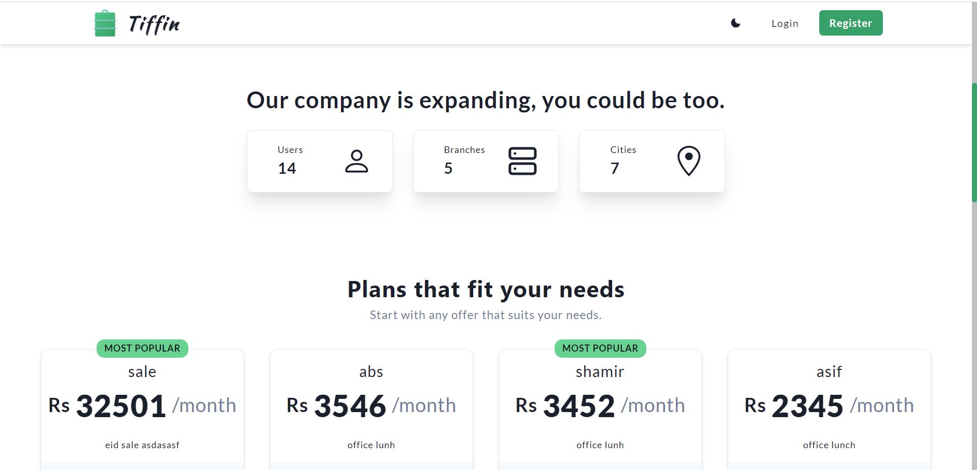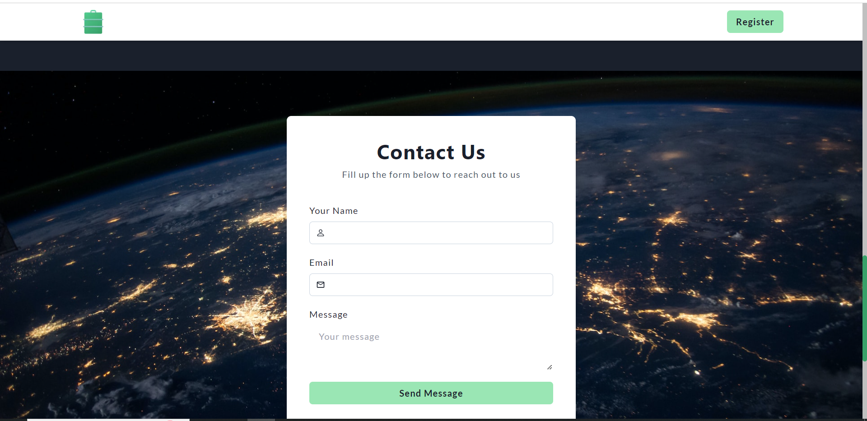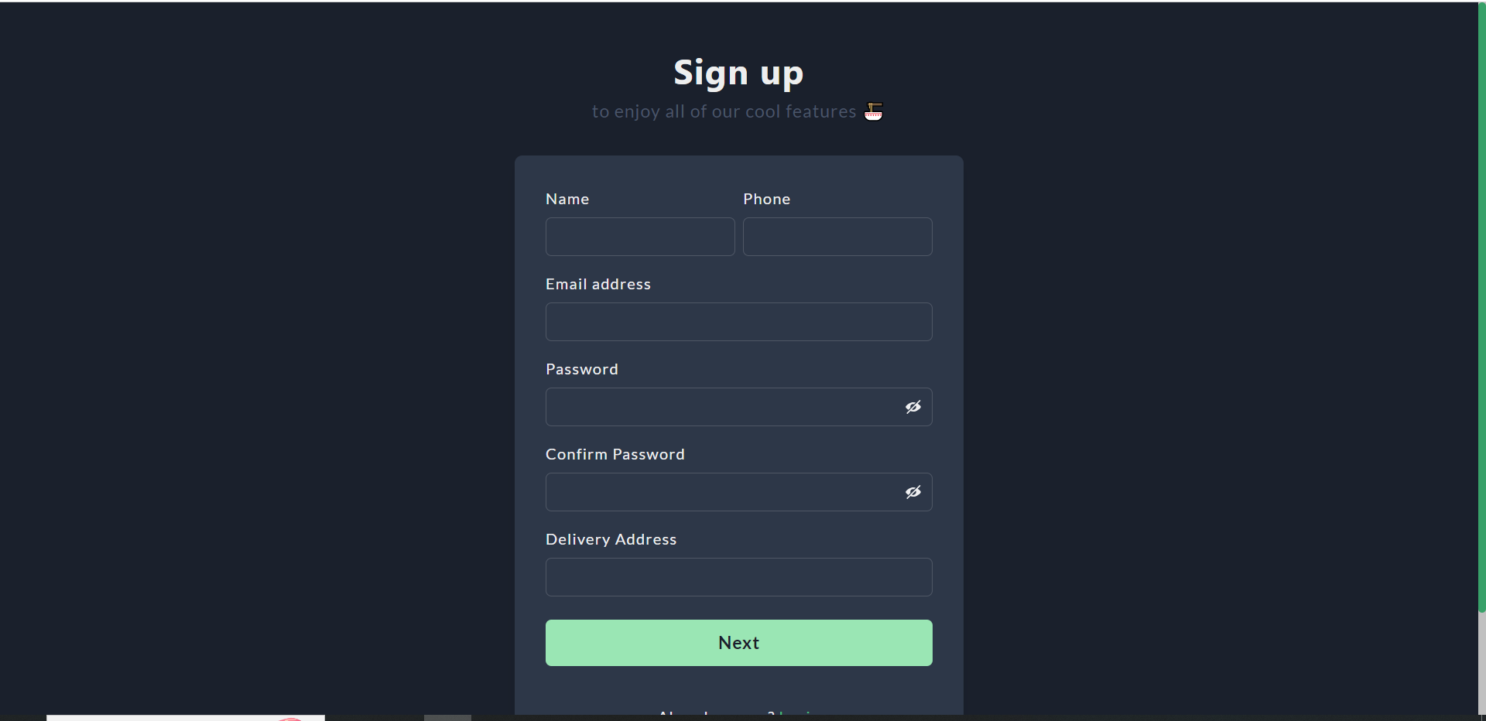

DevThrone:

This website is build in next js. This website is the portfolio website of devthrone.

